 September-October 2019
Chapter Leader: Theresa Phillips TCF National Headquarters

24-Hour Help Line: (816)229-2640 PO Box 3696, Oak Brook, IL 60522
Private Facebook Page: Eastern Jackson County TCF Website: www.compassionatefriends.org
Website: www.easternjacksoncounty tcf.org 630-990-0010

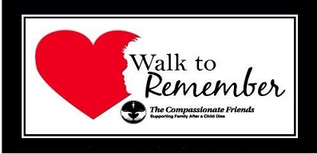
Our Seventh Annual Walk to Remember will be held Saturday, September 21, 2019
At Waterfall Park (just behind Bass Pro) In Independence, MO
Registration will begin at 8:30 am
Walk will begin at 9 am. Registration for the walk is $10. A limited number of shirts will be available the morning of the walk for $10.
More information is available on our website: www.easternjacksoncountytcf.org

As the Tide Recedes
It has been two years since our son Nathan died, and I am often amazed at how much our family has changed during that time. I think of our grieving process as being a lot like a stroll along the beach at high tide. In the beginning, when our loss was fresh and new, the waves of pain were unbearably intense, coming at us without pause. They seemed to hit us everywhere at once--in the face, in the stomach, in our hearts--knocking us down to the ground.
The grief and anger we felt swelled over our heads; we were drowning in emotions we couldn’t understand. And we began to wonder if we would ever be able to breathe normally again. “How can life go on when it hurts so much?” we asked.
But time passed, and the tide receded. The water dropped to our knees. The waves seemed to strike with less frequency, and when they did hit, their power was diminished. But we sensed that we were still not free. Sometimes, when we least expected it, a huge wall of grief seemed to rise out of nowhere, pounding us with the memories. We stumbled but did not fall.
One day, we looked up and discovered that we were walking on only wet sand. We had been battered by the waves, but still stood erect. And we recognized that our loss had given us an enduring strength.
Scattered on the shore before us were beautiful treasures that had previously been hidden by deep water. These treasures, which sparkled like jewels in the sand, were all the priceless memories of our child that we had submerged in our pain. Now it was possible to gather up our thoughts of the happy times and hold them close to our heart.
Today, we walk through the shallow, lapping waves with a new confidence, leaving our wet footprints in the sand. Following behind us, however, there are invisible prints which are quickly washed away by the swirling water. These are the steps which our child will never take.
The past, like the salt of the sea, clings to our skin. We know that the tide will return—with anniversaries, birthdays, holidays and special family occasions—but the grief will never be as powerful or as strong. We have learned to live like the flotsam which floats on the surface of the water.
Ride gently with the waves, let grief carry you forward, so that you will be ready to stand strong and upright when once again feet touch solid ground.
--Janet Lyet Gassman, TCF, Colorado Springs CO
Changing Seasons
I go to the cemetery when the season changes. My only burden now is a floral arrangement. I fuss & clip & clean, dispose of the old, carefully place the new, and test its security against the coming rain, the possible wind.…I sit and talk with you awhile, for years the same routine. How I wonder what you would be like, then take a photograph. I don’t know why; stone never changes. Rows of photos in an album taking the place of ones of you who never change. Photos in an album now only of the changing seasons. I don’t know the reason.
--Fay Hayden, “Heartlines,” TCF Tuscaloosa AL

The Storm of Grief
I have heard grief described as a “process,” heard the words “stages of grief.” Process and stages are such tidy words, and grief is anything but tidy or orderly; it is a mess, much like the storm raging outside my window. A storm that buffets me at its will. Winds that rage, then subside, only to rage again. Rain that drenches me or drizzles and drizzles until I am soaked through.
Sometimes I can hold up an umbrella to take shelter. Other times there is no shelter, the umbrella is torn inside out and ripped out of my hands. I am left alone and vulnerable to the power of the storm raging around and within me.
Sometimes there are moments of sunshine, and I wonder: Why is the sun shining? How can the sunshine at a time like this? It seems almost an affront as the storm rages on inside.
Then there are the quiet moments of resting in the shade until the next storm rises. Some of those who watch me being ravaged by the storm say, “Get on with your life. Get out of the rain. Why can’t you smile? Why can’t you be like you used to?” But the storm is not of my doing—I cannot control the weather. Some accuse me of lingering in the storm, of not trying to get away from it. But the storm follows me wherever I go.
Then there are the precious ones who sit with me in the storm and allow some of it to rage around them too. Somehow, though they cannot change the storm, it doesn’t feel quite so cold and there is a little shelter from the wind.
Often we know that a storm is brewing, and there is some warning, as with special days, anniversaries, birthdays (though what can prepare us for those terrible ‘firsts’?) I can plan a little and so deflect the full power of these particular storms.
But what to do about the freak winds that rise up out of nowhere and take my breath away? A piece of music, smells, sights, movies, meeting one of my child’s friends, married now with children—Where is your life, my love? Where are your children? The triggers are everywhere waiting to hurl me into the center of yet another storm. I wonder, where is the safe haven now?
Some days there is nothing—no rain, no wind, no sun, nothing—just existing in emptiness so deep, I fear I will drown in it.
The days, weeks, months, years pass, and I notice the sun, and care again that it shines. Now I can allow the warmth of the sun to rest on my skin and melt my soul a little.
Somehow, despite myself, I learn to live with the storm, maybe even befriend it a little—learn to accept it as part of my life. If my child had not died, I would not be in this storm. If I didn’t love my child, I would not be in this storm. I cannot change my child’s death; I will not change my love.
--Anna Bardsley
Autumn
In the fall when amber leaves are shed,
Softly…silently, like tears that wait to flow,
I watch and grieve.

Go With the Flow
Why are some people able to successfully navigate change while others have such a hard time? One of the keys is acceptance.
Resisting change is like rowing against the current. Everything lies there ahead of you. But instead, you try to row upstream, back to where you once were.
When you refuse to accept change, you work against the forward momentum taking you to the next phase of your life and remain stuck in the past.
Every thought that begins with I can’t, I won’t, or I don’t equal resistance. Argue with reality, and you’ll lose every time.
Align your boat with the direction of the river. Stop clinging to the rock, let go of the oars and go with the flow.
On the other side of acceptance is where peace exists, where the solutions are. Draw on your [inner] resources…Begin to trust, and you can become the person [you were meant] to become all along.
--Ariane de Vonvoisin

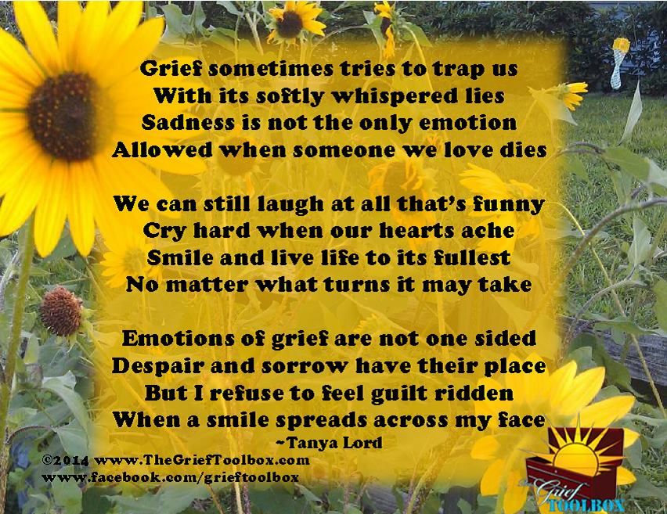

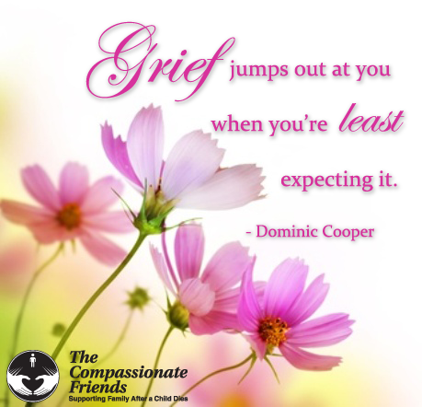

Fall
Will I ever see the leaves turn and wither without thinking of my son’s last days? On the first day of Fall each year my heart aches. Yes, there IS such a physical thing as heartache. It feels like the chest cavity is too small. It hurts.
When I look at the world, the wispy fall clouds look like the sky has a furrowed brow, and occasionally it puckers up and cries with me. The sun is so innocent, so naïve. It casts its rosy glow on every object, oblivious to the gray pain just around the corner. The trees begin to cry their dead leaves onto the ground and stretch their empty arms heavenward (like me), asking “WHY?”
And then I think of my own naïveté five years ago with bittersweet memory. I can’t say I was carefree, but I never knew the terrible aching grief of losing a loved one. For many months after my son died, I longed to escape back to the days before I felt the pain. Now I know that going back is more painful than facing the NOW.
All the other months I live a relatively happy and healed existence, but beginning with that first day that’s truly “autumn” … My heart hurts, my brow furrows, my eyes cry, and even though the warm sun shines on me, my arms feel empty, and they are raised to the heavens asking, “WHY?”
Hurry up, Fall, and move on by. Even the dead of winter is preferable to the pain you bring me each year.
--Donna Ellis, Kansas City, MO

The Death of the Young
People ask: “Why do children or young people die, when they have lived so little?” How do you know that they have lived so little? This crude measure of yours is time, but life is not measured in time. This is just the same as to say, “Why is this poem, this picture, this piece of music so short? Why was it broken off and not drawn out to the size of the longest speech, or piece of music, or the largest picture?”
As the measure of length is inapplicable to the meaning (or greatness) of works of art or poetry, so—even more, evidently—it is inapplicable to life. How do you know what inner growth this soul accomplished in its short span, and what influence it had on others? –Leo Tolstoy

Any Child’s Death Diminishes Me
What difference does it make whether a child is stillborn or dies after some years of life? She spoke of the lack of memories because her child was stillborn. He commented on the deep pain brought by those very memories which remind him of what he lost!
When it comes to a child’s death, does the type of death matter? Is a murder worse than an accident? Suicide worse than chronic illness? Teenage worse than older adult? Stillborn worse than teenage?
I’ve tried to be thankful that Jeanie wasn’t murdered, that she and those dear boys did not linger comatose or die from prolonged illness. I could not find thankful-ness, though I have sought diligently for it within my deepest being!
The death of each child, whatever the age or circumstances, brings its own guilt and anger, its own despair and questioning.
Any child’s death diminishes the parents who love that child, and for those bereaved parents, that death is surely the worst, their grief the most severe! --Robert F. Gloor

Turn Arounds
Sometimes life gives you turn arounds
Things you did not expect
The disappointment breaks your heart.
A total disconnects
You don’t know why this had to be
This horrible event
it’s left you feeling torn in half
the sadness, the lament!
But then, I’ve noticed, time goes by
Initial shock is gone
Although it hurts, I realize
That somehow, I have grown
I’ve met some people, learned some things
I never would have learned
Had this not happened as it did
And somehow, I’ve discerned
That I can take it, I am strong
Much stronger than I knew
Though this still hurts me deep inside
How can it be? I grew!
I still wish I could turn back time
That this had never been
But realize one day I’ll know
just why but until then
I’ll feel my pain and cry my tears
And I will learn to cope
With all this hurt that’s deep inside
I never will lose hope
by Jenny Donaldson
Poems from Sascha Wagner
Summer’s End
Always at summer’s end
there comes that moment
when memory brings to me
gifts from the past.

I see your faces then,
glistening in the sun.
I hear your laughter then,
shared by the wind.

And in the glint of time
I feel you near again,
as you were, long ago,
at summer’s end.

Now Autumn
What a strange time is autumn.
More than a season,
autumn can be like a mood.
Softness and warmth and abundance
drift from the sky like a smile.
And you remember the seasons
before the children died.
They do seem far away sometimes,
those seasons, now.
But not the children—
they are always here
in this strange time, this autumn,
when the softness and the warmth
and the abundance
of unseen children
drift from the sky like a smile.

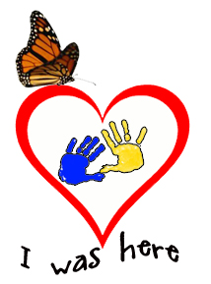

Indian Summer
This may well be
the softest time of all.
Does mild September
still surprise your mind
with memories you thought
you would not have?
Believe me, friend, that
(after many tears)
this may well be
the softest time of all.

If Tomorrow Never Comes
If I knew it would be the last time, I’d see you fall asleep,
I would tuck you in more tightly and pray the Lord your soul to keep.
If I knew it would be the last time that I see you walk out the door,
I would give you a hug and kiss and call you back for one more.
If I knew it would be the last time, I’d hear your voice lifted up in praise,
I would videotape each action and word, so I could play them back day after day.
If I knew it would be the last time, I could spare an extra minute to stop and say “I love you”
instead of assuming you know I do.
If I knew it would be the last time, I would be there to share your day,
well, I’m sure you’ll have so many more, so I can let just this one slip away.
For surely there’s always tomorrow to make up for an oversight,
and we always get a second chance to make everything just right.
There will always be another day to say, “I love you.”
And certainly, there’s another chance to say our “Anything I can do?”
But just in case I might be wrong, and today is all I get,
I’d like to say how much I love you and I hope we never forget.
Tomorrow is not promised to anyone, young or old alike,
and today may be the last chance you get to hold your loved one tight.
So, if you’re waiting for tomorrow, why not do it today?
For if tomorrow never comes, you’ll surely regret the day
that you didn’t take that extra time for a smile, a hug, or a kiss…
that you were too busy to grant someone what turned out to be their one last wish.
So, hold your loved ones close today, and whisper in their ear.
Tell them how much you love them & that you’ll always hold them dear.
Take time to say, “I’m sorry, please for-give me…thank you…[or] it’s okay.”
And if tomorrow never comes, you’ll have no regrets about today.
--Norma Cornett Marek

Moments
Opening the closet looking for the vacuum, you glimpse a shirt hanging there.
Walking down the hall, you pass the closed door.
His cat jumps in your lap and settles in, finding a comfortable spot.
Shopping for groceries you spy the Entenmann’s doughnuts.
A car goes by that you recognize. Was the front plate crooked?
Driving past the tree, you look. You always have to look.
A familiar song plays on the radio.
Moments that poke their heads-up day after day trying to enter your mind and take over.
Moments taking your breath away.
Moments that make you think it isn’t true.
You push them back with all your energy. Ignore therm. Keep busy and they will go away.
But without warning one little moment pokes up, just a fleeting moment appearing out of nowhere.
You have no more strength. It explodes in your mind and takes over your body.
Crying, screaming, hitting, slamming! Asking “why?”
Tears, nausea, dizziness, sweating.
Your body finally goes numb. All feeling is gone. The burst is over.
You pick up the pieces and take one little step. Then another. Face another day.
You see a bird at the feeder.
A butterfly lands on the flower you planted.
The sun peeks from behind a cloud.
A friend calls.
You feel ready to go on.
A hint of a smile appears.
You are gathering your strength.
You feel stronger than ever…
Waiting for those moments to poke at you again.
--Janice Mazza

I don’t know why…
I’ll never know why…
I don’t have to know why…
I don’t like it…
I don’t have to like it …
What I do have to do
is make a choice about my living.
What I do want to do
is accept it and go on living.
The choice is mine.
I can go on living,
valuing every moment
in a way I never did before.
Or I can be destroyed by it and,
in turn, destroy others.
I thought I was immortal,
that my children & family were also,
that tragedy happens only to others.
I know now
that life is tenuous and valuable.
I choose to go on living,
making the most of the time I have.
And valuing my family and friends
in a way I never experienced before.
--Iris Bolton, TCF, North Atlanta
Give Way to Grief
Give way to grief, and, unashamed,
Abandon stoic fortitude a while.
Set free, a while, the soul,
Better to bear its load.
Tears unshed are stones upon the heart
That choke the healing stream.
Unlock the floodgates; loose the waters.
Give way, and cope with grief.
--Melville Cane

Those of us who have
worked through our grief
—and found there is a future—
are the ones who must meet others
in the valley of darkness
and bring them to the rim of light.
--Rev. Simon Stephens, TCF Founder
Some Whys
Why is a person given six weeks to recover from major surgery—but only until after the funeral to recover from the death of a child? Why do people assume you can turn off your feelings for your child? That you can “put it behind you” now?
Why do people say, “It could have been worse” or “I understand; my dog died” and other such hurtful things?
Why do people act worried, and tell you you’re not handling this very well? (Or maybe worse, that you are.)
Why do people tell you this will make you stronger, make your family closer, or “God doesn’t give you more than you can handle”?
Why do people now avoid you altogether, or are surprised and shocked when you mention your child, then change the subject?
Why are you so exhausted, so lacking in energy, so easily confused, and so unable to make even simple decisions?
Why do you feel worse now that you did in the beginning?
Why do we expect people to read our minds? Hard as it is, we must help them understand what we need—and what we don’t.
Why is it so hard for us to admit that this pain is entirely too big, too awful to handle alone? That we need someone who cares—someone who won’t say any of those stupid and hurtful things?
If you need understanding and caring friends, come to several TCF meetings. Without this group, I would not have survived. Try it. What can you lose?
--Karen Story, Montgomery AL TCF
September
As I type this, there is a suggestion of fall in the air. If this is your first fall without your child, and you have been having a few “good” days, but now you seem to be slipping, know this is normal. If this is your first season change, this unexpected mood swing may seem frightening. Change of seasons can be very difficult. Even before the tragedy, our bodies reacted to seasonal changes. The psychiatrists call it “seasonal blues.” Add your grief and it compounds it.
If this is not your first, but you are still affected, don’t be discouraged. This, too, is normal. It takes quite a few before they can be handled better. In addition to how our body is affected, each season has its own set of memories we have to deal with. With fall, there is the beginning of school. No matter what the age of our child, our thoughts can turn to the start of school.…
Fall also means the holidays are coming closer, and it is easy to slip into anticipating them. Try your best not to. Take it one day at a time; don’t look ahead, particularly if you are in your first year. TODAY is what you should try to handle at this time. The TOMORROWS you WILL handle when they get here.
--Mary Ehmann, Valley Forge, PA TCF
Broken Spirit
My spirit has been broken but not lost.
… has been damaged but not beaten.
…has been wrenched, but not forever.
My spirit will find a way to survive
what humans should never endure.
My spirit grows with the strength of
others; let them shout to the world.
We stand before you,
survivors of our children.
Let the world know we have done
what we ask no other human to do—
we buried our children.
My spirit has survived this and more.
May God keep giving me my spirit
to keep going, today and every day.
--Pat McDougle, Murfreesboro TN TCF

In Time
When we grieve and hurt, we seem to be more aware of everyone’s shortcomings, mistakes and limitations.
When we grieve and hurt, we seem to be less capable of forgiveness and understanding.
When we grieve and hurt, we must try to realize that feelings of anger and frustration are natural, and that they are temporary.
In time, we will rediscover our ability
to understand and forgive many people, not only others in the world around us, but also ourselves.
The important word here is “IN TIME.”
--Sascha Wagner, from
The Sorrow and the Light

Ghost Story
“Daddy, Daddy, come with me please.”
To others it’s only the wind in the trees,
but in the soft haze of dusk
when the mind runs free,
the ghost in the woods is calling to me.
He’s spoken often since we’ve been apart
in a voice heard not with ears but my heart,
Down familiar overgrown pathways
he leads me to the creek
where wood duck’s nest in the weeds.
“Over here. Over here.”
By the ghost I’m drawn into the thicket
where he once found a fawn, white spots
on brown in a thick bed of leaves.
Had he not shown me,
I would have believed it was bare.
“Look up, Daddy, look. It’s still there.”
The frayed end of the rope swing
high in the air dangles.
Unused since he left.
Just beyond, past the spring
and the meadow lies the pond.
“Come, come.”
Running ahead, he leads me there
to the sunken log in the corner
where he caught his first fish.
I stand, now alone, while darkness deepens,
then slowly head home,
hearing his voice fade
into the haunting call of the owl.
I stroll through the dark and with hope recall how a few past times
before my walk was done,
I experienced something beyond belief,
as wholly engulfed by memories and love,
for a brief magic moment,
I and the ghost became one.
--Richard Dew, in “Rachel’s Cry”
Second
I used to be second to experience what life has to offer.
Second to walk.
Second to lose my first tooth.
Second to learn how to ride a bike.
Second to learn how to drive.
Things started changing
after your death.
First to graduate.
First to go off to college.
First to turn nineteen.
I’m sick of being first.
I just want to be second.
--By Lisa Yoakum, sister of John
The Pages of Her Life
Time was of the essence.
She came into our world
so tiny, so helpless,
with a heart so complex
and in need of care,
yet so strong.
She was taken
from the womb swiftly.
A tiny cry escaped her.
Two pounds, 9 ounces, 14½ inches
She was our baby.
The doctors whisked her away.
…waiting, wondering, fearing…
The worst came true.
We were to have her only six days.
That morning on March 29, 2007,
a heart so tiny
that had a beat so strong stopped.
And on that day, we lost our Reanna
along with a piece of ourselves.
And we are left with only the memories
that fill the pages of her life.
so sweet so brief so beautiful,
her spirit her life her…
--By Sarah Monroe, Indep. MO

Other available support
Dear Friends - as many of the men know, there is a men's group that meets the second Saturday of each month at Buddy McFadden's house. Chuck Findley started the group here in Kansas City and in other cities. There are several links below to their main website and also a TV station video and article covering the group in Indianapolis and a youtube video. If you are interested in attending the men's meeting send an email to:
Chuck chuck.findley11@gmail.com OR
Buddy buddymac1941@gmail.com, https://www.morningswiththedadsinc.com
https://fox59.com/2014/11/27/grieving-dads-recall-lost-children-on-thanksgiving/
https://www.youtube.com/watch?v=8fP-YyjLY7w&feature=youtu.be

Remember when you came to your first meeting and someone was there who was a little farther down the road and gave you a hug or shared something that made you feel like you are not crazy. Well if you are a little bit farther down the road please feel free to come back to our meetings and help families that are just starting their grief journey.

Upcoming Event 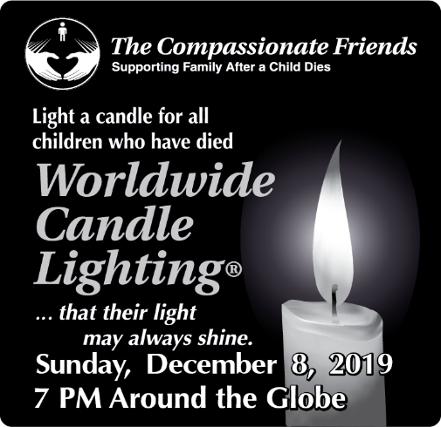
More details will be in the next newsletter and in future emails.

Love Gifts
Thank you for the generous donation from Mark Fanning in memory of his son, Marcus.

Please help us help others. Make a LOVE GIFT today. Tax deductible Love Gifts may be sent to: TCF C/O Theresa Phillips 6200 Kentucky Ave, Raytown, MO 64133
For Remembrance dates please visit our website at www.easternjacksoncountytcf.org
Find us on Facebook at https://www.facebook.com/groups/1582699755290182
We have several volunteers who write remembrance cards to families on birthdays and death dates. Just a reminder if you have an address change please email phillipsplace@aol.com or mail a note to TCF, C/O Theresa Phillips 6200 Kentucky Raytown, MO 64133 so the roster can be updated.
Please remember that you can give to The Compassionate Friends through your United Way pledge at work or as a single gift, but you MUST WRITE IT IN.

