Sept-Oct 2017
Chapter Leader: Theresa Phillips TCF National Headquarters

24-Hour Help Line: (816)229-2640 PO Box 3696, Oak Brook, IL 60522
Private Facebook Page: Eastern Jackson County TCF Website: www.compassionatefriends.org
Website: www.easternjacksoncounty tcf.org 630-990-0010

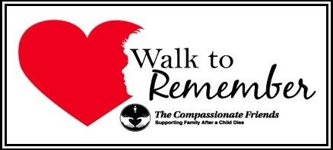
Our Fifth Annual
The Compassionate Friends
Walk to Remember
September 23, 2017 Registration will start at 8:30 AM at
Waterfall Park, Independence MO

A Walk of Love By Mark Rambis, Tony’s dad
We gather today as family.
After an event, almost too painful to recall.
We gather today, unified as one,
To laugh or cry but always standing tall.
With special pictures, posters
And beautifully designed shirts,
We gather today as family
To honor the source of our hurt.
Our feelings can be indescribable.
Sometimes we ache throughout our soul.
It gnaws at our very existence.
It can possess our mind and seize control!
Yet somehow with each other’s help
We gain hope and receive tremendous empathy.
We know we need not walk alone.
So we gather today as family.
Today our eyes will see more than the park.
Our ears will hear more than others can.
We’ll see their smiles and hear their laughter.
We’ll feel their presence and the touch of their hand.
And so we gather today as family.
To walk in the love of each other.
Remembering sons, daughters, grandchildren,
And our beloved sisters and brothers.
It is a day of memories, smiles and laughter.
We’ll walk this park hand -in -hand.
We’ll speak many times our loved ones’ name,
To all who will listen, every woman, child and man.
Their smile, their voice, their memory.
In our hearts, they will forever be the same!
Today we are gathered as family,
For a “Walk to Remember” in their name.

September Song
“I wonder how many people think about what it’s like for a parent not to have to pack a Snoopy lunch pail for their child ever again.” September marks the re-entry of kids into the world of academia…but for some parents it’s the reminder that the excitement of the children that electrifies the air won’t be the same in their homes this year. So many hopes and dreams and memories are wrapped up in what occupies a major part of a child’s life…school time. Summer cushions us from having to be painfully aware that our child won’t be walking to school with the other kids, or won’t be trying out for the lead part in the school play, or won’t fall in love with the girl he sits behind in math class.
Parents who never had the pleasure of “letting them go” to school for the first time know what they missed. They remember their own “first time” and would like to have relived it with their child. They would like to have made it really special and asked all the questions that their own parents asked them when they arrived home from school. Hopes and dreams for this child’s future will never be realized. “I wonder if my neighbor remembers that if my baby had lived, this is the year he would have started kindergarten. I wanted him to have a Snoopy lunch box just like the other kids.” –TCF, Portland, OR

The Fall of Fall
What is it about the season
that takes me back in time?
Everything I do,
I find you are on my mind.
Haunting dreams find me at night
when I try to sleep
and every little detail is replayed,
and the sadness falls so deep.
Something about the close of summer
seems to bring it back,
making it so hard to move onward
and stay on track.
Something about the dying
and fading of the trees
brings my heart to sorrow
with the falling of the leaves.
How I long to stop it,
to keep the fall away
but times marches on,
and summer just won’t stay.
I know with the fall,
winter’s not far behind,
another lonely season,
and the memories flood my mind.
I cry my tears of sorrow,
and pray for spring to come,
a rebirth of the earth
and the warmness of the sun.
It makes the memories soften
and gentler to recall,
but now my life is saddened
with the nearing of fall.
-- Sheila Simmons, in memory of her son Steven (3/24/70-10/19/99)

Autumn

In the fall
When amber leaves are shed,
Softly—silently
Like tears that wait to flow,
I watch and grieve.
My heart beats sadly in the fall;
'Tis then I miss you most of all.

Lily de Lauder
TCF, Van Nuys, CA
The Sign
As a little boy Jody loved to pick Black-eyed Susan. He’d pick those wild flowers and bring them to me with such love and pride in presentation. The last bunch he picked for me was on my birthday before his death, August 4, 1976.
The Black-eyed Susan is an independent wild flower that cannot be forced to grow out of season. The growing period for these wild flowers is the middle of June to the middle of August. But there, the first of September in the year of my son’s death, in the center of Jody’s grave, was a single perfectly formed Black-eyed Susan. It stood with strength and reassurance. It was all alone in the still, unsettled dirt covering the grave. There was not even a blade of grass or a single weed around.
I wept with mixed emotions of intense loss and love, feeling both distance and closeness, sadness and sudden relief. I saw it as a sign from my darling Jody. It spoke to me words from my dead child. “Do not cry. Do not despair. I love you and never intended for you to suffer so much. Please forgive me, and please be happy with the rest of your life. Please believe that I’m okay and at peace.”
Whether it was a sign from Jody or from God, perhaps a bird dropped a Black-eyed Susan seed on the fresh grave, it brought me relief. I felt that my son wasn’t so far away, and that his spirit would always be with me.
If nothing more, it helped me to begin to think of Jody there at the gravesite. He was dead, and I began to accept that. I started to realize that I would never again see his form as I had known it. But his spirit would be close and would guide me. I would not forget him and what we shared. He would always be special. What we gave to one another, what we had meant to each other, would not die or diminish with the passage of years, and it has not.
Each year since Jody’s death, a single Black-eyed Susan has grown on his grave. It is a comfort and a joy. It is a remarkable phenomenon that now makes me smile rather than cry. Joey was a kid who never forgot my birthday, and never outgrew giving his mom flowers. I choose to believe he still hasn’t. There are many mysteries in life and death that can’t be explained, and I think shouldn’t be, just accepted.
Susan White-Bowden
In memory of Jody “From a Healing Heart”
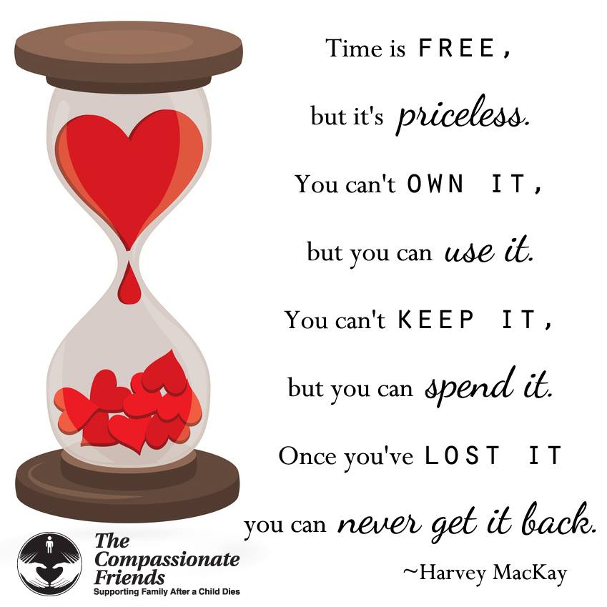

How Long Will The Pain Last?
How long will the pain last?" a broken-hearted mourner asked me. "All the rest of your Life." I have to answer truthfully. We never quite forget. No matter how many years pass, we remember. The loss of a loved one is like a major operation. Part of us is removed, and we have a scar for the rest of our lives. As years go by, we manage. There are things to do, people to care for, tasks that call for full attention. But the pain is still there, not far below the surface. We see a face that looks familiar, hear a voice that echoes, see a photograph in someone's album, see a landscape that once we saw together, and it seems as though a knife were in the wound again. But not so painfully. And mixed with joy, too. Because remembering a happy time is not all sorrow, it brings back happiness with it.
How long will the pain last? All the rest of your life. But the thing to remember is that not only the pain will last, but the blessed memories as well. Tears are proof of life. The more love, the more tears. If this be true, then how could we ever ask that the pain cease altogether? For then the memory of love would go with it. The pain of grief is the price we pay for love.
Where Do I Go?
Now that you’re gone, where do I go
to see your fair smile
to hear your tinkling giggle
to smell your damp hair after a swim
to listen to your questions
to touch your gentle cheek
to feel your bear hug?

Where do I go
to share all my years of wisdom
to find someone who’ll tell me the truth
to answer the phone that won’t ring
to tell you I’m sorry
to know that I am loved and
to pour out my love and my tears?

I shall go
to the pictures that hold you forever
to the books we shared
to the music you taught me to love
to the woods we explored as one
to the memories that never fail
to the innermost reaches of my heart
to where we are always together.
--Marcia Alig, TCF, Mercer, NJ

Did You Know?

Did you know:
you need to rip up sheets
to make a kite that flies.
That you cannot build a fort
without a tree with Y's.
That matchbox cars run better
when they are full of paint.
Or, if you hold your breath too long,
you probably will faint.

Did you know:
a baseball bat
makes a terrific gun.
And, yes, an egg can really fry
when left out in the sun.
And cardboard boxes seem to make
the most terrific trains.
And you can swim in puddles
after gentle summer rains.

Did you know:
that baseball cards
clipped upon your bike
will make the awful clicking noise
that parents never like.
A crab trap can be used to catch
the most exquisite birds
and pig Latin
serves to provide
a private world of words.

And did you know my brothers?
They died a few years back.
The taught me all these marvelous things
That sometimes sisters lack.
--Kathi Guthrie
TCF Cape May County, NJ

There’s No Law Against Grieving--Even for Men

Two years have now passed but I still remember that day like it was yesterday.
If you are reading this, then you have probably lived that day, too. It may have been slightly different—but still the same.
Even though there was a bunch of relatives and friends in the waiting room with me, it was like I was completely alone. I had been called to the hospital less than an hour before. There had been a car accident. My wife was injured but not in danger. But no one would tell me anything about my 8-year-old Stephanie or 5-year-old Stephen who were riding in the car with her.
I had been led to a waiting room, hoping for word from the emergency room doctor. The minutes seemed like hours. Then the doctor came in. Stephanie was in critical condition and would be flown to Children’s Hospital. But they were unable to revive my precious Stephen.
The words echoed over and over in my brain.
“Your son has died.” The shock and the grief struck me at the same time. I had expected them to come in and tell me the kids were injured but would be just fine thanks to the excellent efforts of everyone involved. After all, that’s the way it always happens on “Rescue 911.”
But that wasn’t the way it happened this time!
I only half remember being led back to my wife where I broke the news to her.
A moment later when I had been led into the corridor, someone asked me if I wanted to see my son. I don’t even remember my response—just walking down the hallway, a nurse on each side holding my arms. All I could take were little half steps. My legs had no strength. Through the tears I could see all the nurses and hospital personnel stop everything they were doing and stare at us. Apparently, they hadn’t seen a grieving father before.
Finally, we reached the emergency room at the end of what seemed like the longest corridor in the world. The door swung open and I spotted my son lying on a table at the far end of the room. I was helped to him and then left alone.
Waves of grief overcame me as I looked at Stephen’s sweet face, laying there as if asleep. And the realization that I would never hear his laugh, I would never see him smile, I would never feel his kiss again.
After a few minutes, a nurse came back and told me I would have to go because my daughter was being loaded into the helicopter and I should give her some words of encouragement, even though she might not be able to hear me.
I did that and I was driven to Children’s Hospital where Stephanie died later that night.
The grief that I felt was so intense. The shock was incredible. This couldn’t be happening. Both of my children were dead.
I remember the newspaper reporter who showed up at my house the next day. I had gone home to get some clean clothes and take a shower. On my way into the house she approached me. We sat on the porch and both cried and grieved as I related to her the story of the wonderful life I had spent with my children. This reporter never once stared at me with that critical look that I have seen from others. If translated into words, it would be “Men don’t cry.”
So often men are not allowed by society to grieve. They have to be strong for their wife and their remaining family. How many bereaved mothers have told me that “He holds it all in. He never cries. He never talks about our dead child.” They want me to meet their husband because maybe I can get him to understand it’s okay to open up and feel grief.
I was fortunate that I grew up in a family where it was okay to let my feelings show. If I was beaten up by the school bully, my father and mother let me know it was okay to cry. When the first person I was really close to died, my grandmother, no one told me it wasn’t alright to grieve.
And this upbringing stuck with me. If I’m in a store and Bette Midler’s song “God is Watching Us From a Distance” (Stephen’s favorite tune to sing) comes on, I’ve given myself permission to cry, right then and there. If I read a poem that touches me, I’ve given myself permission to let it all out. And if I hear about the death of another child, I’ve given myself permission to feel my grief all over again.
The only thing bad about men grieving is that society looks down on us because we are not “strong.” After losing both my children, I really don’t care what society thinks. Only a small percent of them have had a child die, and they understand my feelings. The rest of them don’t. And, God willing, they never will.
If you are a man and having a hard time allowing yourself to grieve, look at your inner being. Are you better because you haven’t grieved? Or are you worse? Have your feelings of frustration from not grieving affected your relationship with your spouse or remaining children?
Our deceased children would, no doubt want us to accomplish something meaningful with our lives. They would want us to go on living.
Maybe it is time to grieve so that we can move forward with our lives.
--Wayne Loder, TCF Lakes Area, MI
In Memory of my daughter and son, Stephanie and Stephen Loder

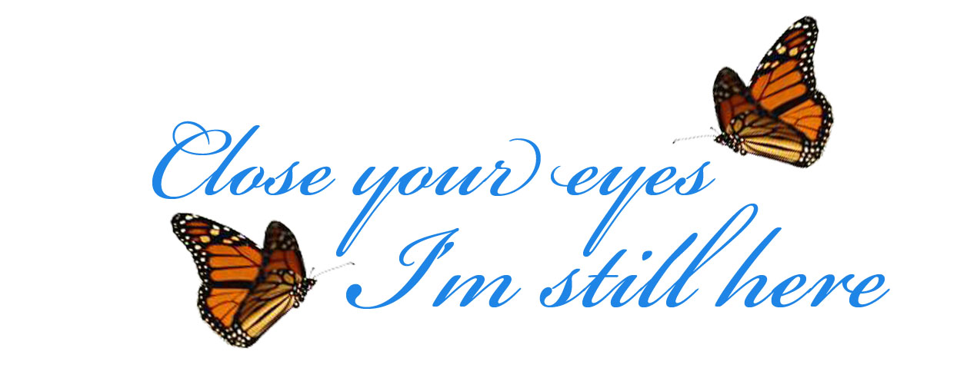

Finding the first yellow leaf…
(how it reminds me of autumn).
Finding the first yellow leaf…
(how it reminds me of time).
Seems like another new year now.
Not the same year I began.
Nothing reminds me of changings
Quite like a summertime gone.
Finding the first yellow leaf
(Will it remind me of grieving?)
Everything golden in summer
Turning to gray after fall.…
--Sascha Wagner
Circle
How do you bear it all?
The cry came from a mother
Whose son had died only weeks before.
We were in a circle, looking at her,
Looking around, looking away,
Tears in our hearts, in our eyes.
How do we bear it?
I don’t know,
But the circle helps.
… by Eva Lager, TCF/Western
Australia (Eve’s daughter Milya
Claudia Lager died by suicide on 4
March 1990.)

A Suicide of a Sibling
© by Susan Kim
Sometimes I wish my sister Amy had died of cancer. Or a car accident. Or something I could neatly explain.
Instead, she died by suicide when she was 18 years old.
I realize that most people are uncomfortable discussing death unless it’s about a great, great aunt who died in her
sleep at the age of 107. But at least if your sibling dies of a disease or an accident, people will say something
relatively appropriate and not feel too uneasy before moving on to a new topic. Not so with suicide.
When my sister first died, I was so in shock, I had no idea how to answer the incredibly insensitive remarks like, “Why did she do it?” “What kind of problems was your family having?” “How did she do it?” Even people who did not ask these questions looked at me with a mixture of pity and curiosity.
To compound the taboo of my sister’s suicide was the fact that sex was mixed up in it. She was an extremely outgoing, creative, charismatic person with no history of mental illness. Everywhere she spent time—church
groups, school, the neighborhood pool— she was the center of attention because it was so much fun to be around her. Two teachers of Amy’s spoke at her funeral, which was standing room only, and shared what a
lasting influence Amy had on people.
So at first the suicide was such a surprise that foul play was considered a possibility before the note was found. In that note, we discovered that she had recently been diagnosed with herpes. You would think that’s not such a big deal in the age of AIDS. But the college she attended was quite conservative, and the health
services department had some awful brochures supplied by the religious right. They basically said your life is over and you’ll never be able to have a child. The nurse there said her diabetes had exacerbated her condition. To top it off, my parents, like most parents, never really discussed sex. That doesn’t mean we kids didn’t know about it, but it did mean that the last people in the world we would ever discuss sex with would be our parents.
Suicide mixed with a sexual disease. It doesn’t make for very good cocktail party chit-chat. So, taking my cue from my parents and society in general, I stopped mentioning Amy. When people asked me how many siblings I had, I would say “two—my surviving younger sister and brother.” It just seemed easier, and people didn’t have to feel so squeamish talking to me.
But two events changed that. One was a conversation I had with my mother about Amy. I thought, at least with a family member, I could discuss her. We were talking about travel—Amy’s passion was traveling to Greece—and I was reminiscing about how enthusiastic Amy was about traveling and how much fun it would have been to see Greece with her. My mother said she just couldn’t talk about it. It made her too sad. This was years after Amy’s death. What the heck did she mean we couldn’t talk about it? If I couldn’t discuss Amy with my mother, then who could I? I turned to her and said, “If I die before you, I hope you won’t refuse to talk about me.” I told her that I knew Amy would want us to remember her —and there are so many incredibly great memories. I called my brother and sister afterwards and told them the same thing: “If I die, please don’t pretend I didn’t exist. I’m telling you here and now that I want to be remembered.”
The other event happened very recently. I’m on a nonprofit board for an organization that helps women working in the Internet industry with career advice. We had a speaker who talked about women over 40 working in the cyber biz. She talked about working as a chat host and said that one of the chats she hosted was about suicide. She mentioned her son who had died of suicide. I thought, “Here’s a woman my mother’s age who is telling a room full of strangers about her son’s death.” It was immensely comforting to see how she handled the topic. You could tell she had a wonderful relationship with him.
The board asked her to join our organization. I pulled her aside and asked about the suicide chat. I told her that my sister had died that way. She told me how sorry she was and asked her name. It’s the first time in my life I was completely at ease discussing Amy’s death. I knew the look she gave me was of empathy, not of pity, not of curiosity. She wasn’t being judgmental, thinking, “What kind of dysfunctional family do you come from?” Unless you have an immediate family, member who died of suicide, no one can ever know the incredible pain and emotional baggage that come with it. I told her later that I get frustrated when people tell me they know what I’m going through because their grandmother died of heart disease recently. I am sorry, but it is not the same. A grandmother has lived a full life. She is not leaving behind middle-aged parents and young siblings who ask, “What could I have done to prevent this?”
I suppose there will always be extra emotional baggage tied to a suicide of a family member. But not discussing it isn’t going to make that baggage any lighter. In fact, by not talking about it, I was contributing to the taboo associated with it. Of course, this doesn’t mean I’ll introduce it into every casual conversation. From now on, however, when people ask me how many siblings I have, I’ll let them know the whole truth—I have a younger sister and brother, and I had another wonderful sister named Amy, who died of suicide.

As Long As I Can
As long as I can, I will look at the world for both of us.
As long as I can, I will laugh with the bird, I will sing
with flowers, I will play to the stars, for both of us.
As long as I can, I will remember how many things on
this earth was your joy. And I will live as well as you
would want me to live, as long as I can.
.. by Sascha. (Sascha’s son Nino drowned at age 3; years later, her daughter Eve died by suicide at age 21.)

You’re Here, Now You’re Gone
You’re here.
Now you’re gone.
It went just that fast.
Where’d it begin? Where’d it end?
Like a flash of lightning in the sky.
So bright and full of life.
Now gone and full of emptiness.
How’d it start? Why didn’t it stop?
No one knows, but everyone cares.
Your spirit is flowing in the air.
You’re not here, but you’ll never be gone.
You will always rise with the morning dawn
You hold my heart
It will never be torn apart.
… by Catherine Ludlow, in memory of her sister,
Cynthia, who died by suicide on June 24, 1993.
________________________________


I don’t know why.
I’ll never know why.
I don’t have to know why.
I don’t like it.
I don’t have to like it.
What I have to do is make a choice about my living.
What I do want to do is accept it and go on living.
The choice is mine.
I can go on living, valuing every moment
in a way I never did before,
or I can be destroyed by it and,
in turn, destroy others.
I thought I was immortal.
That my family and my children were also.
That tragedy happened only to others.
But I know now that life is tenuous and valuable.
So, I am choosing to go on living,
making the most of the time I have,
valuing my family and friends
in away never possible before.
..... from the book, My Son, My Son, by Iris Bolton, whose son Mitch died by suicide.

from Song of Myself
All goes onward and outward, nothing
collapses,
And to die is different from what any
one supposed,
and luckier….
They are alive and well somewhere,
The smallest sprout shows there is
really no death,
And if there ever was, it led forward
life, and does not
wait at the end to arrest it,
And ceas’d the moment life appear’d.
…Walt Whitman (1819-1892)

Falling for you….
…. while leaves fall, the river drifts by and friends sit, speaking of loved ones lost to
suicide. Like the river, conversation drifts. Some smile at memories shared. Others cry
tears of regret, anger, guilt, despair; tears for what could have been, but is no more.
Through the years, this group of friends has learned that words fall short of describing
sorrow. And so, we sit silently, watching the….

…. falling leaves…. falling tears…. falling for you….
…. until the time comes to fall in line and drift toward a table adorned with recently fired clay shapes. At an earlier gathering, I molded soft gray clay then impressed it with words and symbols of your life. Although I don’t speak of it, I know that yours is not the only life interrupted. My life is also damaged, diminished, in danger of falling apart in oh so many ways. This small group shares space with those we miss and love, both living and dead; in this, my child’s birth and death season. How I long to see you float free with
the….
.... falling leaves…. falling tears…. falling for you….
….and I long to connect again with you but my plea falls on deaf ears. I’m left with the task of creating your wind chime. A year ago, on your birthday, leaves fell as I stamped the soft clay heart with musical notes, falling stars, hovering doves and the words “treasured memories.” Now the clay has cured and along the holes in the edge of the stamped heart, I tie other clay shapes with lengths of string – my heartstrings. I add an anchor, a porcelain leaf inscribed with the words “falling in love.” The pieces fall in place like….

…. falling leaves…. falling tears…. falling for you….
….and then I playfully brush my fingers through your wind chime; fingers that long to
run through your hair. The chime whispers your name but its music can never fill my heart like the sound of your voice. Fall – a time for friends to make wind chimes and
memories. A time for…. falling leaves…. falling tears…. falling eternally for you.
Carol Clum
TCF Medford Oregon

… in the Autumn
Some people love to see the changes
in the colors of the leaves,
When the sky is clear and dark blue
as the sea.
They love to smell the oak leaves burning
But it is then my heart is yearning
To be with ones I know
I cannot see.
There's something in the autumn
That makes my heart so heavy,
I miss them all but know they're where
they should all be.
If I can make it through the winter,
And see the spring unfold before me,
Then I'll know once more they're
there, and wait for me.
When the morning sun comes later,
and the afternoons die early,
And my spirits drop like leaves
around my feet.
I'm so aware that I am mortal
and I can almost see the portal
that I will pass through and be
evermore complete.
Jim O'Neil
TCF, Montgomery, AL
TIME
Time is like a train
Taking me ever farther away from you;
Miles and minutes,
Hours, days, months, ten years farther
Until I fear the last time your curly hair
Tickled my cheek in a good-bye hug
Will become a distant memory
Trailing like fading smoke behind me.

Time is like a tyrant
Tormenting me with water torture
Of my soul;
Grief falling drop by suffocating drop,
Until visions of your dancing blue eyes
Threaten to drown me in the maddening
Drip…drip…drip… of pain

Time is like a thief
Trying to take the rest of you, bit by bit,
From my mind.
Sights, sounds, smells, slowly steal away
Until I fight back
With 24 years of mementos & memories
And a half-empty bottle
of your favorite cologne
Becomes my strongest defense.

Time is like a tide
Trapping me on a foreign shore
Where shards of your loss
bury themselves deeply in my heart
Until ebb and flow roll
briny waves of healing
Around the debris of your demise,
And I can remember the glow of your pearly smile without sobbing.

Time is like a train
Taking me ever closer to you:
Miles and minutes,
Hours, days, months, ten years closer,
Until I reach the place where
time and tears are no more
And I never have to say good-bye to you again.
--Robin Church Wolf, “in love and remembrance of my son, Gary Edward Gentry Hester, 8/1/69-7/20/94

It’s the Music
That Bonds the Soul
The room you once lived in
Doesn’t look the same.
The people who used to call you
Never mention your name.
The car you used to drive,
They may not make any more.
All the things you once treasured
Are boxed behind closet doors.
The clothes you set the trends by
Are surely out of date.
The people you owned money to
Have wiped away the slate.
Things have changed and changed
Again, since you went away.
But some things have remained the
Same each and every day.
Like this aching in my heart…
A scar that just won’t heal,
Or the way a special song
Can change the way you feel.
Brother, you must know
That the “music” bonds us
And will always keep us close.
Because, secretly, I know in my heart,
It’s the music you miss most.
So, let the world keep on turning
And “time” can take its toll
For as long as the music keeps playing,
You’ll be alive and dancing in my soul.
--By Sibling Stacie Gilliam,
TCF, Oklahoma City, OK

Now
Your presence now fills me
with that which I never had before,
a knowing that love is what remains
when all else is gone;
a sureness that death is not an end
but a beginning in another time
and place, yet still connected
by what holds you to me.
Like sparks afire we go on,
both of us filling our pinpoints of light,
our souls, with what we need
to be bigger than we are
next time we fly away,
together, to NOW.
--Sandy Goodman
On Your Birthday
I wrote this date this morning, paused,
And felt the room grow cold.
It always does
When I remember all of it—
Down to the last petal tossed by winds
Above the upturned earth.
This time the chill
Does not leave so easily.
It would have been your birthday.
Soon I shall be
As old as you will ever be.
--Wanda M. Trawick, TCF, Acme, PA

Mark your calendar for this upcoming chapter event:

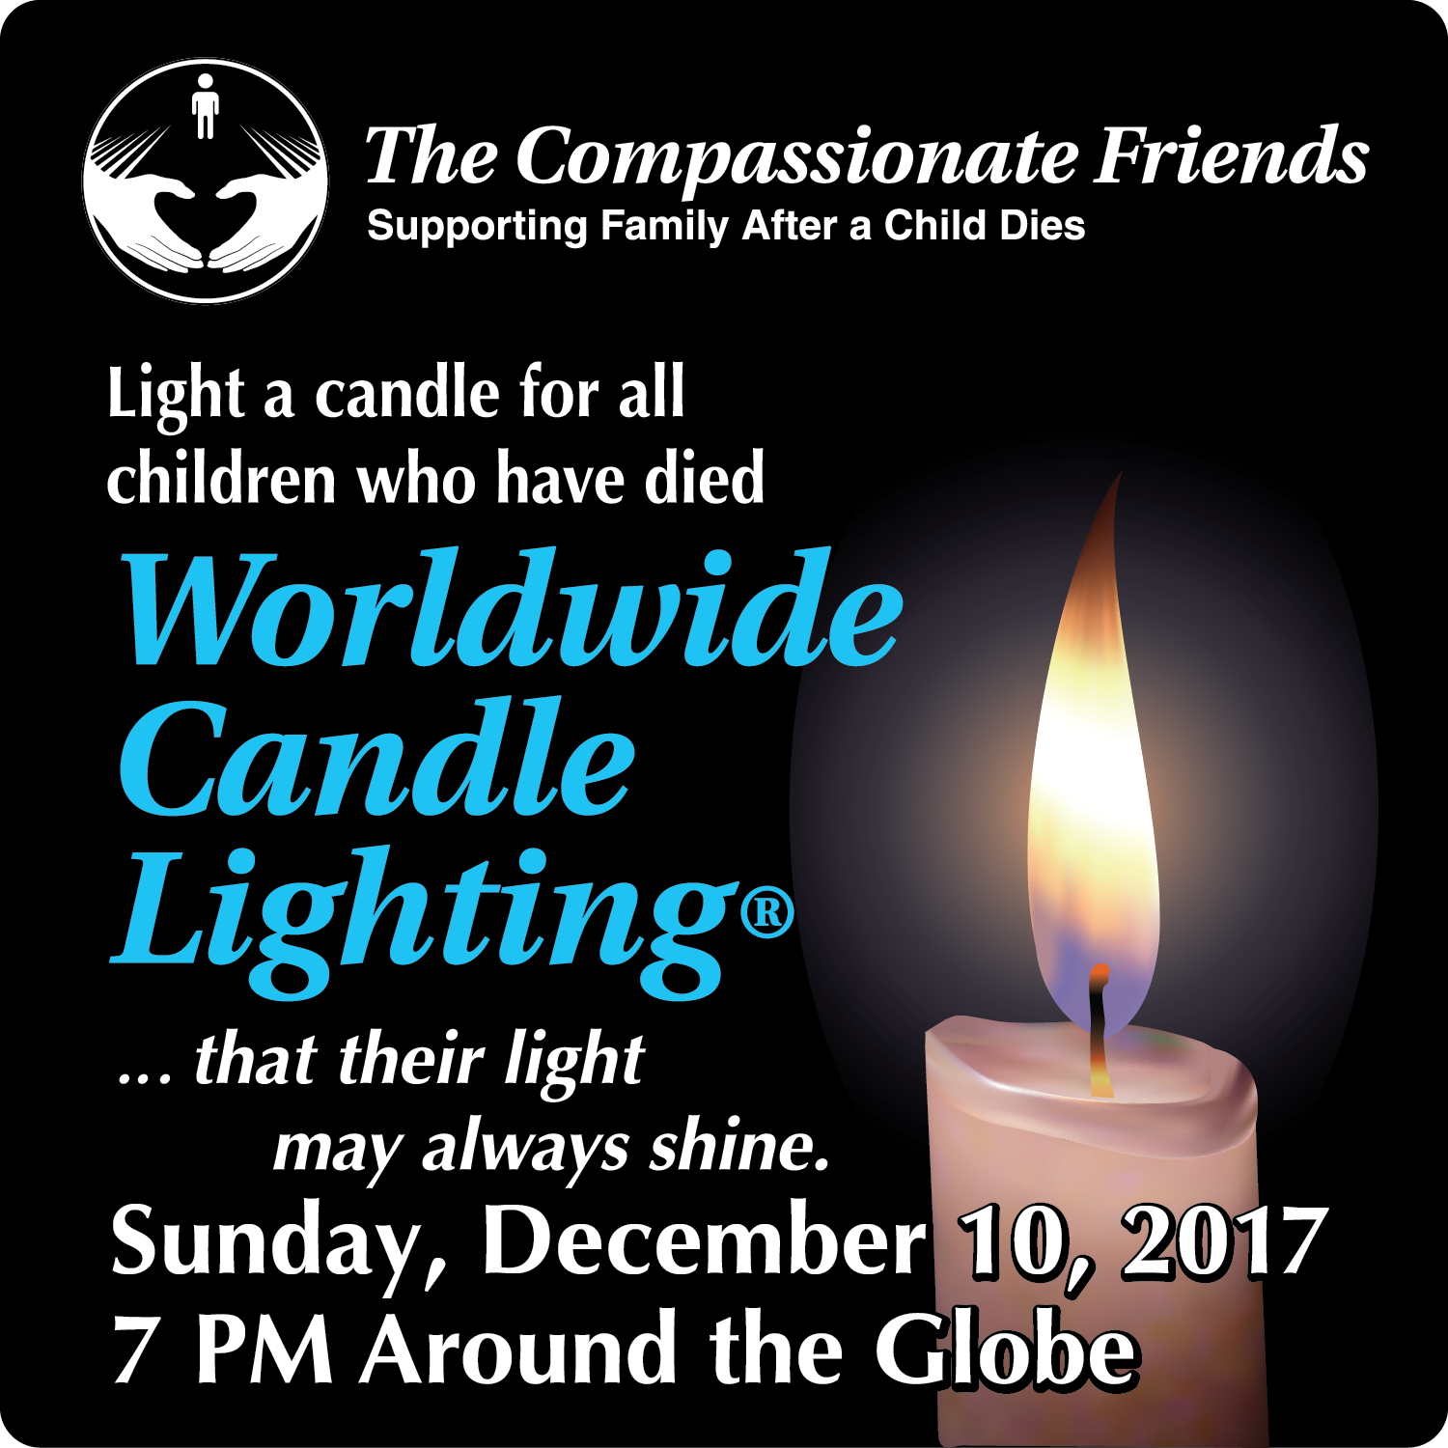

For Remembrance dates please visit our website at www.easternjacksoncountytcf.org
Find us on Facebook at https://www.facebook.com/groups/1582699755290182
We have several volunteers who write remembrance cards to families on birthdays and death dates. Just a reminder if you have an address change please email phillipsplace@aol.com or mail a note to TCF, C/O Theresa Phillips 6200 Kentucky Raytown, MO 64133 so the roster can be updated.
Please remember that you can give to The Compassionate Friends through your United Way pledge at work or as a single gift, but you MUST WRITE IT IN.
TCF asks for donations in memory of our children who have died. Our activities support the grief work of many families. We also work to educate members of our community about the grief process & how they can support bereaved parents.
Please help us help others. Make a LOVE GIFT today. Tax deductible Love Gifts may be sent to: TCF C/O Carol Cavin 214 E Hansen Ct, Independence, MO 64055

