 Sept- Oct 2018
Chapter Leader: Theresa Phillips TCF National Headquarters

24-Hour Help Line: (816)229-2640 PO Box 3696, Oak Brook, IL 60522
Private Facebook Page: Eastern Jackson County TCF Website: www.compassionatefriends.org
Website: www.easternjacksoncounty tcf.org 630-990-0010

September
The unofficial end of summer. The time by which we need to have new school clothes and supplies. The time to meet new teachers and new friends.
“The time to…what?” Watch with tear filled eyes as the bus picks up other children for school, but no longer stops by our house. To see other parents standing with their eager little ones, waiting for that first school bus ride to the “big” school. To see tears of joy in the eyes of other parents through the tears of pain in our own.
Time to watch with anxious anticipation as the kids begin middle school. New experiences, new expectations, new fears. Time to wonder if we told them enough to keep them safe from peer pressure. Time to wonder if we are giving them too much freedom or not enough. Time to learn that saying “I love you” must be done in private. Time to realize that with us, “I love you” will always be said in silence.
Time to watch our teenagers experience high school and its freedoms and decisions. Time to hand over the sports coaching to someone we don’t know. Time to wonder if our child is taking too many academic hours. Time to wonder what temptations await our children. Time to wonder about the car they bought. Time to realize these things are happening to some other parent.
Time to buy single bed linens for the college dorm. Time to buy a new computer to take to school and keep the old one for us. Time to get an extra credit card for the student, “just in case.” Time to give last minute instructions about calling home every Sunday night. Time to listen to other parents talk about these experiences.
No, for us, Labor Day is just that—a day to labor through the memories left behind by the loss of our child, a day that truly signifies the end of the summer of our life.
--Sondra Wright, TCF, Atlanta
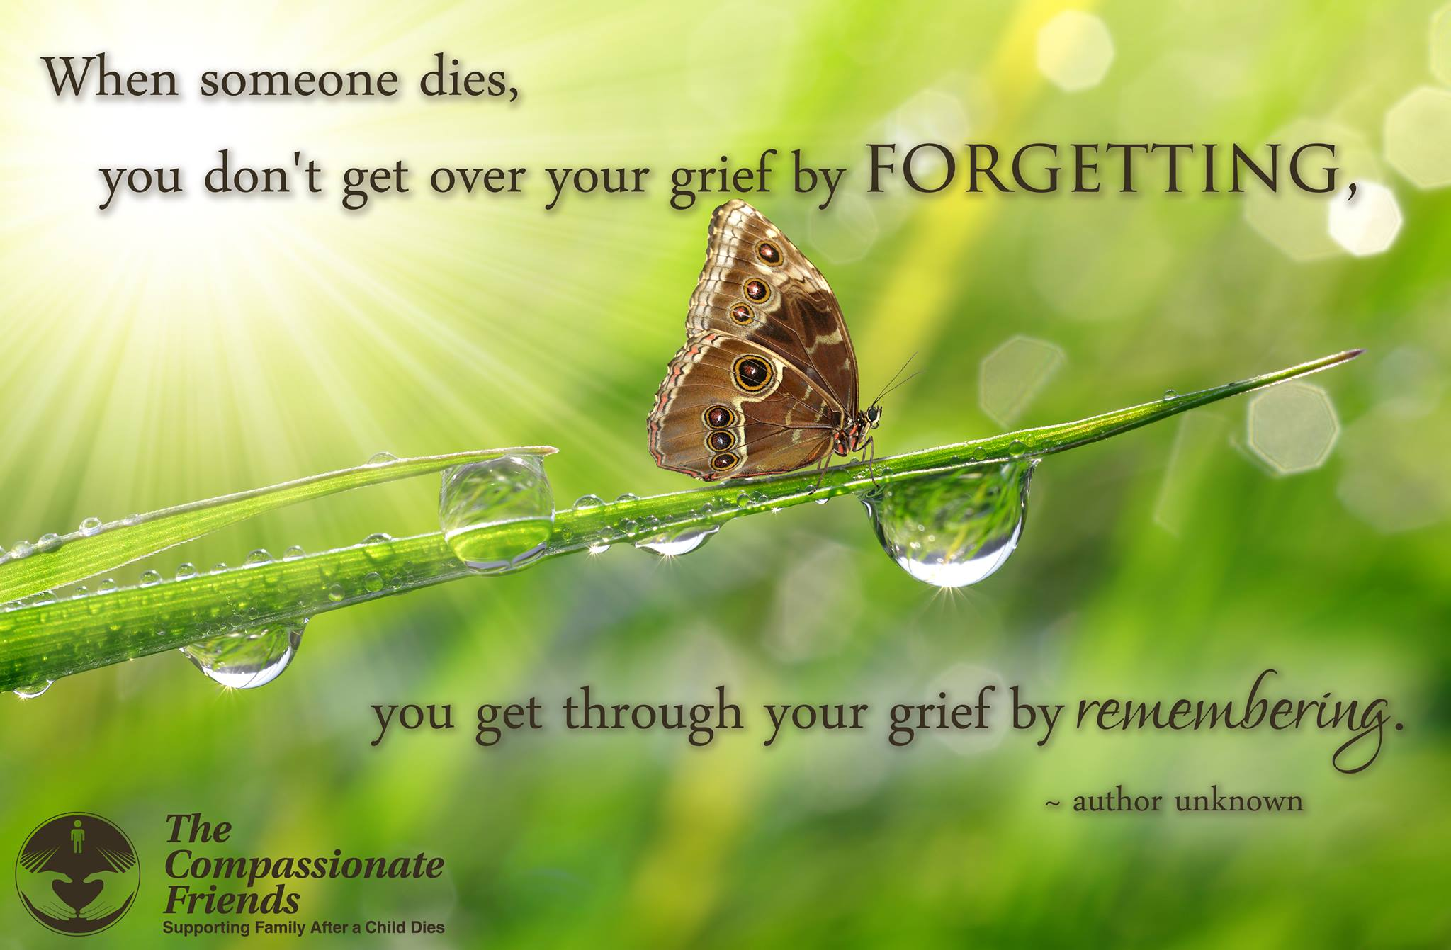
In Fall
Things often are
most beautiful
before they leave us—
As autumn ends,
she spends her final glory
on us, who hurt
when we remember spring.
--Sascha Wagner
When autumn lingers in the gleaming trees
with painful beauty, golden melancholy—
When we recall the wealth of bygone harvest
and wait the haunting of a lifeless winter—
hope is so far away, spring is so far away.
But spring will come!
--Sascha Wagner

The Back-to-School
Pressure Cooker
Labor Day can put siblings into their own back-to-school pressure cooker. Whether this is the first year or later, our kids may be dealing with questions and comments about their brother or sister from peers, teachers, or counselors. Or perhaps no one is talking, because no one knows what to say. Feelings of loneliness, being different, being left out, can surface—and sibling rivalry? Remember, if you will, how intense it could get between all your children. What kind of competition existed between them during the school year, or what comparisons were made: athletics, grades, friendships, extra activities?
That kind of emotion is often forgotten when a child dies. But as your children go back to the classroom, to the athletic field, they may see those reminders each day. When they bring home these feelings, positive and negative, they need a place to express them without being judged or compared to their sibling.
We want to remember the good. But we have to remember that no child was always good! To forget that is to make a martyr of our dead child—possibly at the expense of our living children.
Our surviving children need special support at this time of year too. They need to be reassured that they are still loved—that they can be forgiven for any anger or resentment they may feel toward their brother or sister…that perfection is not a requirement for loving. They need to be reassured that they are separate, unique individuals, not imperfect replacements for the child who died. They need a safe place to talk, to let out their own concerns and anxieties and fears. They too are grieving and need a lot of support, especially during this back-to-school rush.
--Cindy Cooper, St. Louis, MO
Indian Summer
This may well be
the softest time of all.
Does mild September
still surprise your mind
with memories you thought
you would not have?
Believe me, friend, that
(after many tears)
this may well be
the softest time of all.
Now Autumn
What a strange time is autumn.
More than a season,
autumn can be like a mood.
Softness and warmth and abundance
drift from the sky like a smile.
And you remember the seasons
before the children died.
They do seem far away sometimes,
those seasons, now.
But not the children—
they are always here
in this strange time, this autumn,
when the softness and the warmth
and the abundance
of unseen children
drift from the sky like a smile.
-Sacha Wagner

I don’t know why…
I’ll never know why…
I don’t have to know why…
I don’t like it…
I don’t have to like it …
What I do have to do
is make a choice about my living.
What I do want to do
is accept it and go on living.
The choice is mine.
I can go on living,
valuing every moment
in a way I never did before.
Or I can be destroyed by it and,
in turn, destroy others.
I thought I was immortal,
that my children & family were also,
that tragedy happens only to others.
I know now
that life is tenuous and valuable.
I choose to go on living,
making the most of the time I have.
And valuing my family and friends
in a way I never experienced before.
--Iris Bolton, TCF, North Atlanta

Those of us who have
worked through our grief
—and found there is a future—
are the ones who must meet others
in the valley of darkness
and bring them to the rim of light.
--Rev. Simon Stephens, TCF Founder

Some Whys
Why is a person given six weeks to recover from major surgery—but only until after the funeral to recover from the death of a child? Why do people assume you can turn off your feelings for your child? That you can “put it behind you” now?
Why do people say, “It could have been worse” or “I understand; my dog died” and other such hurtful things?
Why do people act worried, and tell you you’re not handling this very well? (Or maybe worse, that you are.)
Why do people tell you this will make you stronger, make your family closer, or “God doesn’t give you more than you can handle”?
Why do people now avoid you altogether, or are surprised and shocked when you mention your child, then change the subject?
Why are you so exhausted, so lacking in energy, so easily confused, and so unable to make even simple decisions?
Why do you feel worse now that you did in the beginning?
Why do we expect people to read our minds? Hard as it is, we must help them understand what we need—and what we don’t.
Why is it so hard for us to admit that this pain is entirely too big, too awful to handle alone? That we need someone who cares—someone who won’t say any of those stupid and hurtful things?
If you need understanding and caring friends, come to several TCF meetings. Without this group, I would not have survived. Try it. What can you lose?
--Karen Story, Montgomery AL TCF
Broken Spirit
My spirit has been broken but not lost.
… has been damaged but not beaten.
…has been wrenched, but not forever.
My spirit will find a way to survive
what humans should never endure.
My spirit grows with the strength of
others; let them shout to the world.
We stand before you,
survivors of our children.
Let the world know we have done
what we ask no other human to do—
we buried our children.
My spirit has survived this and more.
May God keep giving me my spirit
to keep going, today and every day.
--Pat McDougle, Murfreesboro TN TCF

September
As I type this, there is a suggestion of fall in the air. If this is your first fall without your child, and you have been having a few “good” days, but now you seem to be slipping, know this is normal. If this is your first season change, this unexpected mood swing may seem frightening. Change of seasons can be very difficult. Even before the tragedy, our bodies reacted to seasonal changes. The psychiatrists call it “seasonal blues.” Add your grief and it compounds it.
If this is not your first, but you are still affected, don’t be discouraged. This, too, is normal. It takes quite a few before they can be handled better. In addition to how our body is affected, each season has its own set of memories we have to deal with. With fall, there is the beginning of school. No matter what the age of our child, our thoughts can turn to the start of school.…
Fall also means the holidays are coming closer, and it is easy to slip into anticipating them. Try your best not to. Take it one day at a time; don’t look ahead, particularly if you are in your first year. TODAY is what you should try to handle at this time. The TOMORROWS you WILL handle when they get here.
--Mary Ehmann, Valley Forge, PA TCF

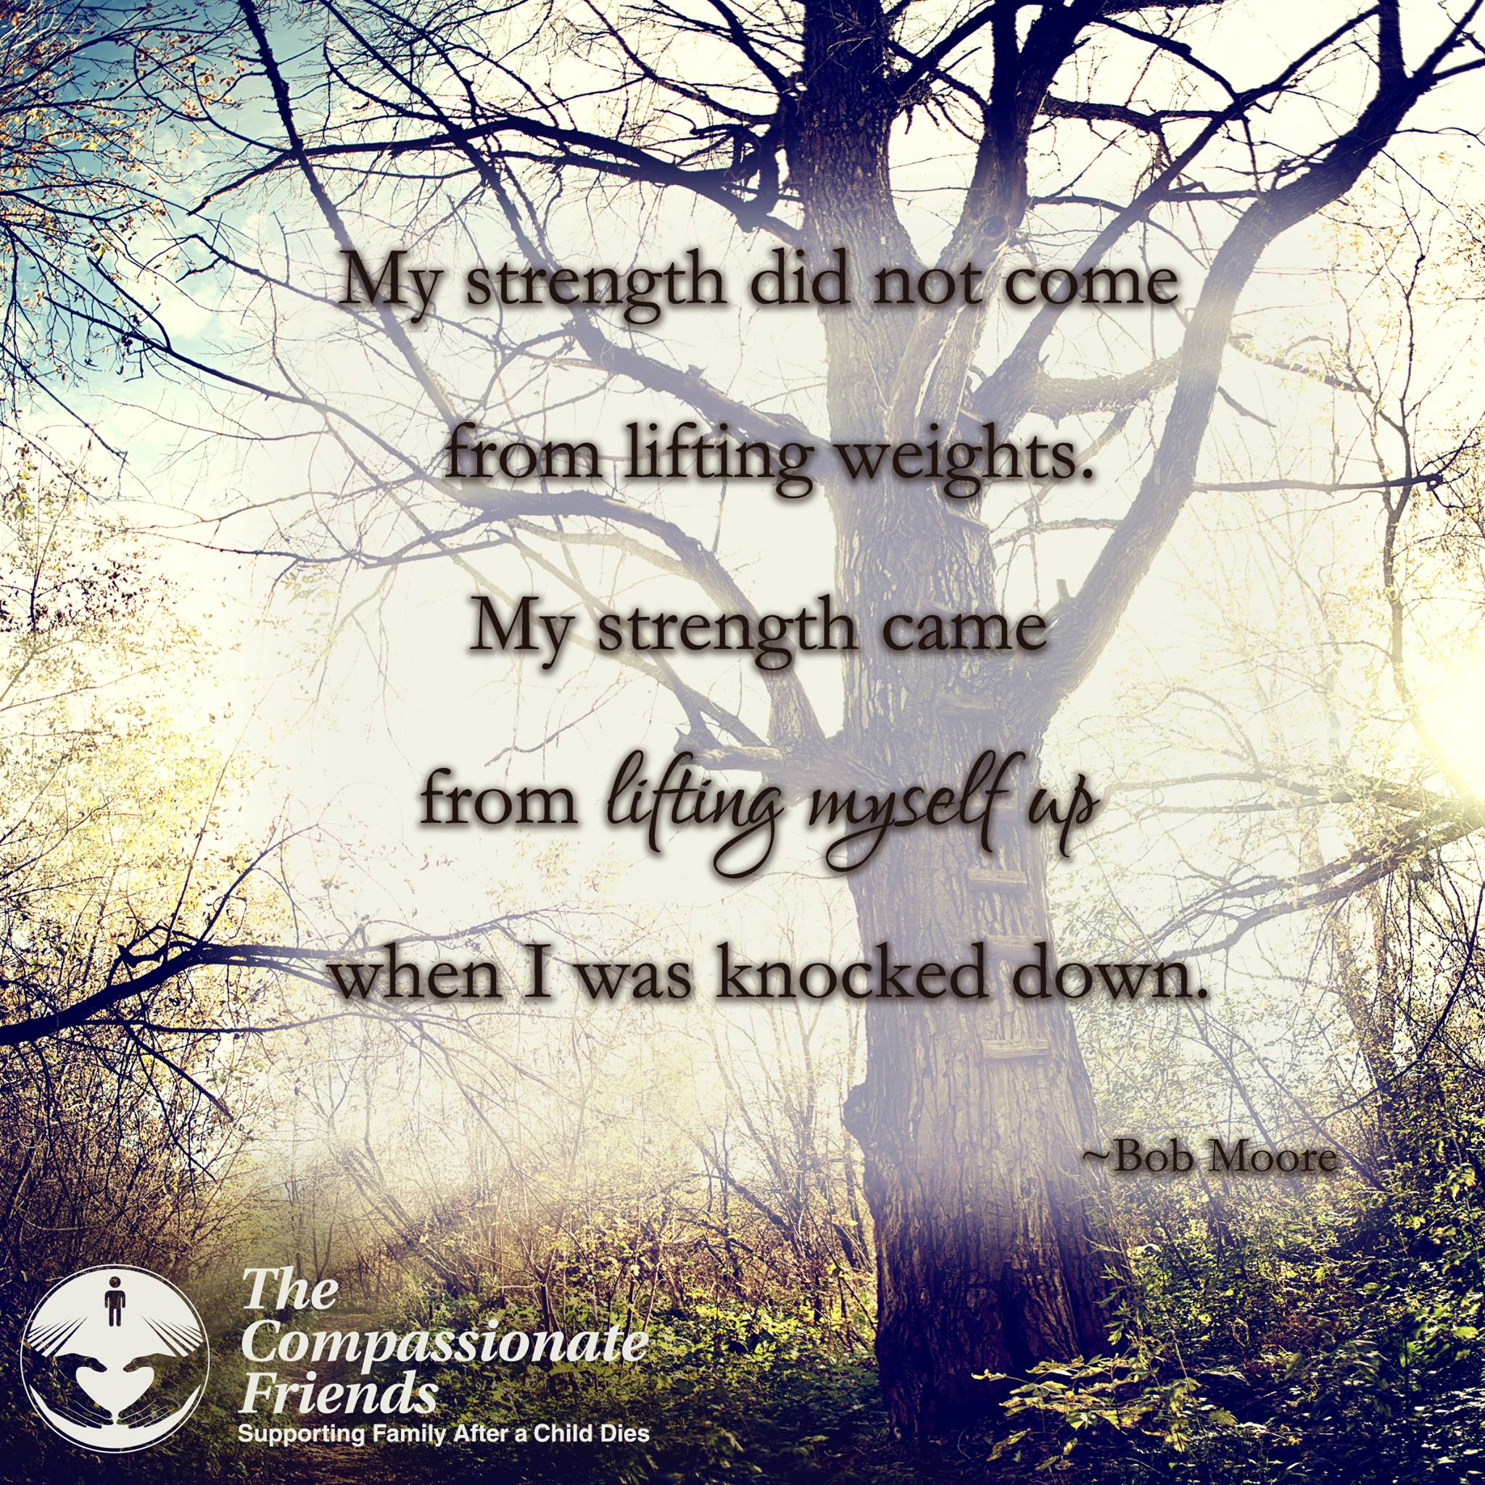

Autumn
In the fall when amber leaves are shed,
Softly…silently, like tears that wait to flow,
I watch and grieve.
My heart beats sadly in the fall;
It’s then I miss you most of all.
In Time
When we grieve and hurt, we seem to be more aware of everyone’s short comings, mistakes and limitations.
When we grieve and hurt, we seem to be less capable of forgiveness and understanding.
When we grieve and hurt, we must try to realize that feelings of anger and frustration are natural, and that they are temporary.
In time, we will rediscover our ability
to understand and forgive many people, not only others in the world around us, but also ourselves.
The important word here is “IN TIME.”
--Sascha Wagner, from
The Sorrow and the Light

As the Tide Recedes
It has been two years since our son Nathan died, and I am often amazed at how much our family has changed during that time. I think of our grieving process as being a lot like a stroll along the beach at high tide. In the beginning, when our loss was fresh and new, the waves of pain were unbearably intense, coming at us without pause. They seemed to hit us everywhere at once--in the face, in the stomach, in our hearts--knocking us down to the ground.
The grief and anger we felt swelled over our heads; we were drowning in emotions we couldn’t understand. And we began to wonder if we would ever be able to breathe normally again. “How can life go on when it hurts so much?” we asked.
But time passed, and the tide receded. The water dropped to our knees. The waves seemed to strike with less frequency, and when they did hit, their power was diminished. But we sensed that we were still not free. Sometimes, when we least expected it, a huge wall of grief seemed to rise out of nowhere, pounding us with the memories. We stumbled but did not fall.
One day, we looked up and discovered that we were walking on only wet sand. We had been battered by the waves, but still stood erect. And we recognized that our loss had given us an enduring strength.
Scattered on the shore before us were beautiful treasures that had previously been hidden by deep water. These treasures, which sparkled like jewels in the sand, were all the priceless memories of our child that we had submerged in our pain. Now it was possible to gather up our thoughts of the happy times and hold them close to our heart.
Today, we walk through the shallow, lapping waves with a new confidence, leaving our wet footprints in the sand. Following behind us, however, there are invisible prints which are quickly washed away by the swirling water. These are the steps which our child will never take.
The past, like the salt of the sea, clings to our skin. We know that the tide will return—with anniversaries, birthdays, holidays and special family occasions—but the grief will never be as powerful or as strong. We have learned to live like the flotsam which floats on the surface of the water.
Ride gently with the waves, let grief carry you forward, so that you will be ready to stand strong and upright when once again feet touch solid ground.
--Janet Lyet Gassman, TCF, Colorado Springs CO
The Storm of Grief
I have heard grief described as a “process,” heard the words “stages of grief.” Process and stages are such tidy words, and grief is anything but tidy or orderly; it is a mess, much like the storm raging outside my window. A storm that buffets me at its will. Winds that rage, then subside, only to rage again. Rain that drenches me or drizzles and drizzles until I am soaked through.
Sometimes I can hold up an umbrella to take shelter. Other times there is no shelter, the umbrella is torn inside out and ripped out of my hands. I am left alone and vulnerable to the power of the storm raging around and within me.
Sometimes there are moments of sunshine, and I wonder: Why is the sun shining? How can the sun shine at a time like this? It seems almost an affront as the storm rages on inside.
Then there are the quiet moments of resting in the shade until the next storm rises. Some of those who watch me being ravaged by the storm say, “Get on with your life. Get out of the rain. Why can’t you smile? Why can’t you be like you used to?” But the storm is not of my doing—I cannot control the weather. Some accuse me of lingering in the storm, of not trying to get away from it. But the storm follows me wherever I go.
Then there are the precious ones who sit with me in the storm and allow some of it to rage around them too. Somehow, though they cannot change the storm, it doesn’t feel quite so cold and there is a little shelter from the wind.
Often, we know that a storm is brewing, and there is some warning, as with special days, anniversaries, birthdays (though what can prepare us for those terrible ‘firsts’?) I can plan a little and so deflect the full power of these particular storms.
But what to do about the freak winds that rise up out of nowhere and take my breath away? A piece of music, smells, sights, movies, meeting one of my child’s friends, married now with children—Where is your life, my love? Where are your children? The triggers are everywhere waiting to hurl me into the center of yet another storm. I wonder, where is the safe haven now?
Some days there is nothing—no rain, no wind, no sun, nothing—just existing in emptiness so deep, I fear I will drown in it.
The days, weeks, months, years pass and I notice the sun, and care again that it shines. Now I can allow the warmth of the sun to rest on my skin and melt my soul a little.
Somehow, despite myself, I learn to live with the storm, maybe even befriend it a little—learn to accept it as part of my life. If my child had not died, I would not be in this storm. If I didn’t love my child, I would not be in this storm. I cannot change my child’s death; I will not change my love.
--Anna Bardsley
Give Way to Grief
Give way to grief, and, unashamed,
Abandon stoic fortitude a while.
Set free, a while, the soul,
Better to bear its load.
Tears unshed are stones upon the heart
That choke the healing stream.
Unlock the floodgates; loose the waters.
Give way, and cope with grief.
--Melville Cane

I’m Not Ready Yet
We should know better by now. It shouldn’t keep surprising us, but it does. No matter how hard we try, no matter what we do to prepare ourselves, it still happens. Year after year, generation after generation, it arrives without hesitation or delay. It stays too long and never lasts long enough. It is filled with anticipation and dread, and we never learn enough, and we know far too much.
It is greeted with great joy and heavy despair. And it is always announced by the universal cry of I’m not ready yet…” The HOLIDAYS are coming, and I haven’t even cleaned up the fireworks from the Fourth of July. I’m still unpacking boxes (we’ve moved…again!) and the calendar says it’s TIME for the annual migration of memories and the Great Stuff the Turkey contest (the turkey won last year). Because we’re in another new place, there will be the dilemma of where to put the tree and how do we explain to the company about that one empty stocking?
Nothing fits this year…The kitchen is too small for the turkey and the flamingoes are going to freeze in the 20 below temperature. I haven’t memorized my address and the grocery store is in the wrong place.
…I’m busy knitting little sweaters for the flamingos left over from life in the SWAMP and practicing with the snow shovel. I keep forgetting where I’ve hidden gifts I bought last summer, and nothing seems to fit in the place like it did in the last one!
We were comfortable in the last place…but then I forget that is what we said when we first moved there too. We always seem to be more comfortable in the last placer…at least we know where the memories are and where to put them and how to handle them. Here in the new place, no one knows our “story.” No one knows our history…it is as if we have NO PAST. It’s easy to blend in, and not so easy to settle in…and The holidays are coming, and I’m not ready yet….
I’m not ready yet…the universal cry of all living beings. I’m not ready yet for first grade, for crossing the street by myself, for sleep-away camp, for junior high, for getting married, for getting a job, for having children, for burying someone I love. I’m not ready yet…for grieving, for handling the holidays, for stuffing a turkey, for finding a place for everything, for living where no one knows my story. I’m not ready yet… for Halloween, for Thanksgiving, for Hanukkah …or for blizzards or frozen pink flamingos.
I’m not ready for the annual flood of memories that always spill out as we unpack the stockings from their tissue wrapped nest. I’m not ready yet…for the clutch of pain that still wraps my heart in grief as we place the ornaments on the tree. I’m not ready yet…for opening the door to greet strangers who are fast becoming friends but who may never know the effort it has taken to be who I am now.
I’m not ready yet to be “normal” and take my place among the normal people of the world. We look normal. For the most part we act normal. (We do, however, have sweater clad pink flamingos in the yard, holding our SEASON’S GREETINGS sign…) We are normal…except for OUR STORY and for the tears in our family fabric. But no one knows those tears anymore and I don’t think I’m ready not to have a past just yet. I don’t think I’m ready for no one to remember our hurt, let alone the joy our loved ones gave to us.
I unpack the silver today, intending to polish it and place it in the dining room so it would add its shimmer to the festive decorations. I wasn’t ready for the flood of memories that came back when I traced my fingers over the delicately carved designs in the coffee pot, remembering my mother patiently teaching me how to polish good silver. I wasn’t ready for the loneliness that swept over me as I placed the tea pot on the tray and suddenly wanted to call MOM and tell her I was, at last and again, home. She had taught me that silver always spoke of a comforting home…and now that I had found it and set it out, I wanted someone to remember with me all those talks my mom and I had shared.
I’m not ready yet…to live only on the surface of life. I want to share my history with my new friends, yet it seems unfair to me to spoil their holiday season. It’s not the same for me; there is still a lot of empty in my heart. Not as much as before, but now the emptiness comes from being too new anywhere to really belong.
So…I’ll just have to figure out how to handle the holidays I’m never going to be ready for in places I may never be settled in. As long as …the silver is polished and ready, then let the holidays come! We’ll figure out how to tell enough of our history, so we won’t be lonely and so people will understand about the flamingos and the tiny empty chair and the joy that lights up our life when we grasp hands together in the family circle.
We’ll decorate our new house (your new life?) with the treasures that speak of our history, finding joy in the memories they spark. We’ll bring with us some of the old, add a few pieces of new and practice the art of blending yesterday with today in hopes of creating another memory for tomorrow. I guess it doesn’t matter if you have moved or have never left the same place for generations, it is still an unsettled feeling the first time no one remembers the journey you’ve been on. The first time no one mentions your child’s name starts a hollowness in our being that leaves us empty and feeling alone. It is as if the world has bade its move again and everything that once was so awkward and out of place has now assumed a “normal” atmosphere and most of the world “forgets” the price we paid for this “near normal.”
I’ll hand the special ornaments, enjoy the silver tea pot and cherish the warmth of the love these gifts of remembrance bring. No one else has to know the story for me to acknowledge it and remember it. No one else has to know the pain for me to share the joy of having these things be a part of my NOW. We’ll gather together and count our blessings, not only naming the ones around the table, but including those whose lives have touched ours in countless ways. One does not have to be present to be alive in the hearts of those who shared a few moments of the journey together. The heart never forgets …even when the world does.
No, nothing fits this year, just like nothing fit last year or the year before. But it’s getting better, improving either with age or experience or patience. Or maybe it’s because it is simply becoming a thread in the continuing fabric of our lives. We will probably always be a bit unsettled, unnerved when the roll call finds a name missing or a chair empty. But, then why shouldn’t we be a little sad when a light goes out in our world?
So, this holiday season, gather in your blessings and count them ALL, knowing that no one else has to know about them for them to be real for you. Just because no one else knows THE STORY does not mean it is any less real. Count the blessings of the people in your story and find the peace that comes with counting a holiday of joy remembered & love shared.
Peace to us all…wherever we may be. --From If I Could Just See Hope by Darcie D. Sims
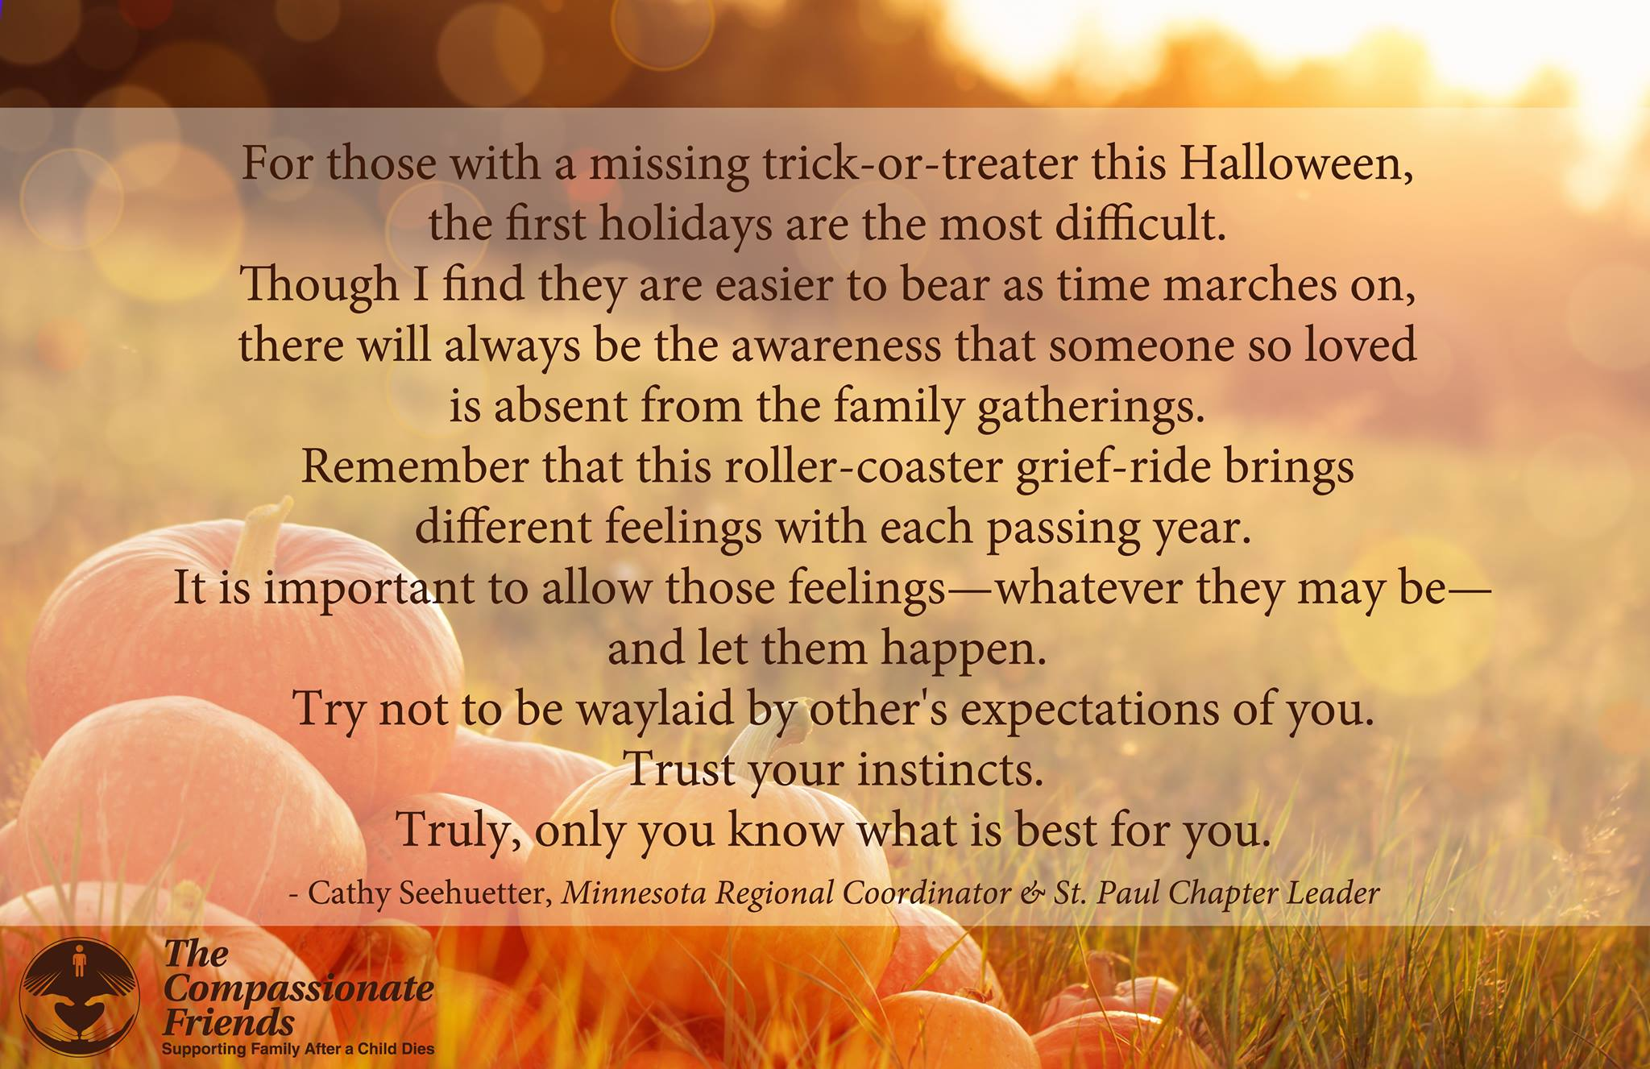
On Halloween
Dusk brings a masked parade
Of children to the door.
Dressed up, they come in twos and threes;
Small ghosts wrapped up in fresh designer sheets,
A pair of GI Joes, a giggling Minnie Mouse,
One witch whose long, green rubber nose
Hangs from her chin.
And clowns whose lipstick
Smiles are smeared and mixed
With chocolate stains.
They ring the chimes, thrust out
brown sacks
Half filled with popcorn balls and sweets.
They come all evening long.
Then, much later, when black nightfall hides all but
The pumpkin’s jagged, candled eyes,
A boy appears, alone.
He wears a vampire’s opera cloak, and
Smiling, bares his plastic, blood-tipped fangs.
His satin cape, his eager stance,
Perhaps the way he tilts his head,
All call to mind another Halloween,
Another boy, my own. Long dead.
This straggler gazes, pleased, as though his
“Trick or Treat” indeed had frightened me,
Then waits till I extend my hand around the door to fill his fists with M&Ms.
Then, porchlit, wait to watch him elbow up his cape before his face,
Then whirl, and fade into the shadowed street.
Alone, I hear his feet strike gravel,
His laughter greets a friend,
And, listening, know
His coming shows All Hallows Eve
to be true;
A night when spirits do arise to walk
And do steal in although we close
And bar the door of vaulted memory.
-- Don Rude

It’s Bittersweet at Halloween
This month is the time for the little funny-looking creatures appearing at our doors for a trick or treat. Halloween was never my favorite day of the year. I think it was because I could never come up with those cute original costumes for my girls like every other mother managed to do every year. It seemed like after answering the door and seeing 200 original costumes I’d always think to myself, “Why didn’t I think of that?” I’d tuck a few ideas away in my head for the next year, but when the time came to execute those ideas, I had tucked them so far away I couldn’t remember them.
Once again, we were scrambling around the house on October 31st trying to come up with ideas that both girls would be happy with. There was a difference of six years between our two daughters, and that wasn’t the only difference. Kirsten’s candy would last until Easter, and then we’d throw it out. JoAnn would eat her candy from house to house and come home with a full stomach and empty bag.
In the summer of 1978, JoAnn had her second open heart surgery. She died July 2, 1978, at age 6. When October rolled around, I dreaded seeing the little children coming to the door, remembering how JoAnn loved the candy and the enthusiasm of the evening.
As the evening wore on, I realized that the neighbors and people who knew us had, no doubt, told the children not to come to our house. My emotions were very mixed up. On the one hand I knew the parents were trying to protect us from the first holiday experience without JoAnn. It was very kind of them. On the other hand, it only reminded me of how different our home was now. When 9 o’clock came it was a relief to know the first event was over.
It has been many years now since Jo Ann died. Halloween doesn’t bother me, but we all know that the next day we turn the calendar, and November is here with the holidays around the corner. These are hard times whether you are a newly bereaved parent or have lived a number of years since your child died. We need not walk alone but reach out to each other. One of the greatest blessings to me now is the gift of memory. I cherish the happy memories of JoAnn in all the seasons of the year.
--Cindy Holt, TCF, Jamestown, NY
October’s Memories
October’s here, the air is bright,
The leaves decked out in fancy dress,
The clouds in shapes of animals
Hang in the sky so blue.
This was our time of year, your favorite.
How many times did you come in,
Cheeks glowing, eyes sparkling,
Smelling of the leaves you jumped through
As a child and even after you grew up.
How many times did you say
“Just smell, just feel the air.
I love it, crisp,
With a hint of winter coming.”
Our time, but now only my time.
Time to dream dreams that won’t be.
Time to wish wishes that can’t come true,
Time to remember and treasure each day we had together.
Time for October’s memories.
--Arden Lansing, TCF, Northfield, NJ

The Mask: “A Way of Life
for a Bereaved Parent”
People say, “Oh my, oh my,
It’s amazing how you’re getting by.
I don’t think that I could be so strong
if such a thing happened to me.”
But such persons are never around
When I remove the face of a clown,
And there for all the world to see
Is a person destroyed by tragedy?
So, I look at people & give a grin
Hiding the sickness, I feel within,
And hope that I will find a way
To get me through another day.
--Laraine Rodriguez,
TCF, Staten Island, NY
Little Baby
Little baby who was not to be,
You were a person . . . at least to me.
Would your eyes be blue?
Or hazel and dark?
Would you caw like the crow?
Or sing like a lark?
Would you have ten little fingers and ten tiny toes?
A rosebud mouth, a turned-up nose?
Would you be laughing and happy?
Or somber and quiet?
Would you run and jump or rather be still?
Would you like to read, or prefer to play?
None of my questions will have an answer.
Your chance to live will never be.
The only thing I truly know . . .
Little baby,
We would have loved you so!
-Joan D. Schmidt

Halloween (and other) Masks
The month of October brings with it a smorgasbord for the senses. We hear the crunching and crackling of leaves under our feet. We see brilliant reds, oranges and yellows splash the earth. We feel the magical approach of winter in the air. October also brings Halloween, a date synonymous with masks.
As bereaved parents we have, at various times, worn many varied masks. We have masked our feelings of despair, sorrow and anguish for the sake of our loved ones, friends and acquaintances. We have masked our feelings of anger and bitterness for the traditional belief that a kind God would not do this to innocents. Most importantly, we have masked the person we have become, the person that has evolved after living through the death of a child.
Let us celebrate the month of October by beginning to take off some of our masks. A helpful way to begin this process is to attend the next Compassionate Friends meeting. Share your sorrow, your fears, your bitterness and disappointment. Above all, share your progress and triumphs through the arduous journey of grief. When you enter a room full of caring and supportive people who share your grief, there is no reason to wear a mask.
--Cathy Crawford,
Camden County Chapter

Ghost Story
“Daddy, Daddy, come with me please.”
To others it’s only the wind in the trees,
but in the soft haze of dusk
when the mind runs free,
the ghost in the woods is calling to me.
He’s spoken often since we’ve been apart
in a voice heard not with ears but my heart.
Down familiar overgrown pathways
he leads me to the creek
where wood ducks’ nest in the weeds.
“Over here. Over here.”
By the ghost I’m drawn into the thicket where he once found a fawn,
white spots on brown
in a thick bed of leaves.
Had he not shown me,
I would have believed it was bare.
“Look up, Daddy look. It’s still there.”
The frayed end of the rope swing
high in the air dangles,
unused since he left.
Just beyond, past the spring
and the meadow lies the pond.
“Come. Come.”
Running ahead, he leads me there
to the sunken log in the corner
where he caught his first fish.
I stand, now alone,
while darkness deepens,
then slowly head home,
hearing his voice fade
into the haunting call of the owl.
I stroll through the dark and with hope recall a few past times
before my walk is done.
I experienced something beyond belief,
as wholly engulfed by memories and love,
for a brief magic moment,
I and the ghost became one.
--From Rachel’s Cry, A Journey
Through Grief by Richard A. Dew, MD

I carried you for nine long months
looking forward to your birth
Little did I ever know
you'd never breath on earth
I'd made such plans for your life,
looking forwards to bringing you home
I never thought for one second
When I came home I’d be alone
They said there been some complications,
they said that you had gone
I couldn't understand their words
What had happened? What had gone wrong?
Now they don’t want to talk of you
the people who drop by
They think that I should just accept
my baby's in the sky.
I’ll keep a part of you with me
and everywhere I am you’ll be
I know we’ll meet again someday
Then in my arms you'll always stay
Every day I’ll think of you
think of you with love
My precious little baby,
my angel up above.
R.I.P. Landon Shane Matthews
Every day is becoming more and more and different and mommy is numb in one place frozen with pain and hurt held inside while the world just passes by!!! I love you baby boy and can’t wait until I’m heaven with you to stay!! Rest easy my precious little angel!!!
-Ivory Jade Matthews

Love Gifts
Please help us help others. Make a LOVE GIFT today. Tax deductible Love Gifts may be sent to: TCF C/O Theresa Phillips 6200 Kentucky Ave, Raytown, MO 64133

UpCOMING EVENTS:

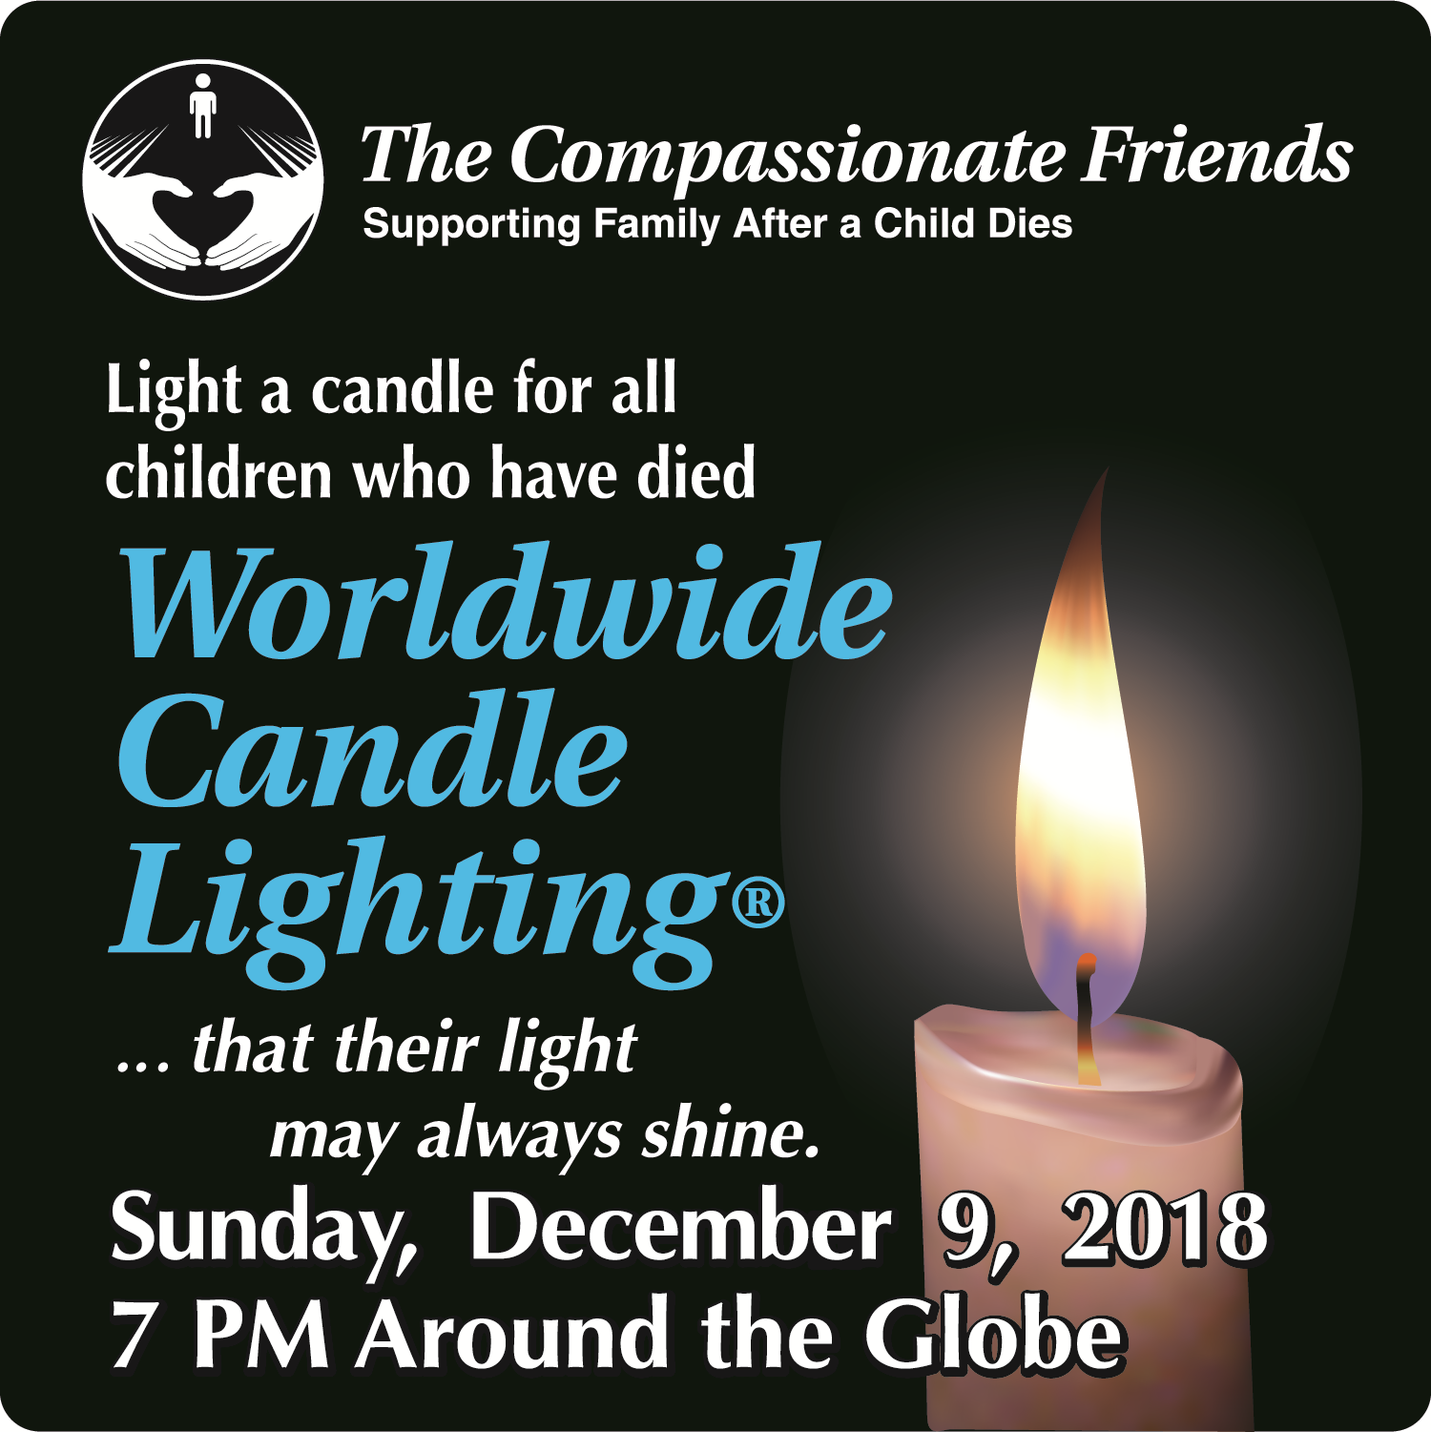

Independence and South Kansas City will Participate in the Worldwide Candle Lighting

Sunday, December 9, 2018 at 7 pm

At Walnut Gardens Community of Christ

19201 RD Mize Rd Independence, MO

For Remembrance dates please visit our website at www.easternjacksoncountytcf.org
Find us on Facebook at https://www.facebook.com/groups/1582699755290182
We have several volunteers who write remembrance cards to families on birthdays and death dates. Just a reminder if you have an address change please email phillipsplace@aol.com or mail a note to TCF, C/O Theresa Phillips 6200 Kentucky Raytown, MO 64133 so the roster can be updated.

Please remember that you can give to The Compassionate Friends through your United Way pledge at work or as a single gift, but you MUST WRITE IT IN.

