 March-April 2018
Chapter Leader: Theresa Phillips TCF National Headquarters

24-Hour Help Line: (816)229-2640 PO Box 3696, Oak Brook, IL 60522
Private Facebook Page: Eastern Jackson County TCF Website: www.compassionatefriends.org
Website: www.easternjacksoncounty tcf.org 630-990-0010

Joe’s Easter Basket
As I got out my Easter decorations, it took me back to happier years, when my kids were small, and the Easter Bunny was still “real.” Joe was the youngest of our four children, and when he died 2 ½ years ago, I felt as though it was time to put the Easter baskets away. I asked my other kids if they minded if we skipped the baskets from now on. They agreed, they were too “old” for the Easter Bunny.
But it was impossible for me to put away Joe’s. When I got it out the first year after his death, it still had a few jelly beans, etc., in it and a small surprise for me. The year before, Joe had seen commercials on television for a new spiral handled toothbrush. He bugged the daylights out of me to buy him one. I was very stubborn, telling him they weren’t worth the money.…The battle went on each time he was with me at the store, or he saw the commercial on television. It was fun to “ruffle” his feathers and heckle him, he took it so well.
For Easter that year, I bought him a spiral handled toothbrush. I remember buying it at the store and laughing to myself, thinking about how Joe would react when he found this silly toothbrush hidden in his basket. I knew he would say, “I knew I would win.” And he did.
My “surprise” in the bottom of his basket—I found the box from that crazy toothbrush. I cried, then I had to laugh remembering the fun I had picking on him. I wondered to myself, why didn’t he throw the box away? Why was it tucked down under the grass? It was as if he wanted me to find it and to have just one more chuckle over that silly toothbrush! Yes, his toothbrush is still in the bathroom, as I reminded myself. My other kids have moved out, and yet their toothbrushes remain, so why not Joe’s?
Everybody wonders what to do with the Christmas stocking; my dilemma was what to do with the Easter basket. As I looked at the Easter basket, I decided then and there to use it to decorate my kitchen table. I also use it to take snacks along to a gathering—a nice seasonal touch and a small quiet reminder of my wonderful son! Happy Easter, Joe!
--Janet Keller

Easter and Passover—
The Seasons of Grief
The seasons take on new meanings when a child dies. The snow of winter melts into the first breath of spring. How well I remember the first spring of my grief. I looked forward eagerly to its coming. Surely when the long dark days of winter are past, spring will be better!
How surprised I was at tears springing forth with the discovery of each new crocus and every bursting bud and spring flower. Yes, spring was beautiful, but oh, so sad, that first year without my son to share it. For suddenly I realized that he was the one who gave me my first bedding plants for Mother’s Day each year.
And now, the Lenten season unfolds once more, and I’m aware of other bereaved parents who will withdraw to the privacy of their personal and painful world of memories with this new season for them. Ash Wednesday…Easter… Passover…these are a totally new experience in the first years of grief. The liturgical words are a thousand years old, yet tears blur the painful newfound meaning.
To walk through grief is not easy; when the shock and numbness have gone, we are left with the reality that life includes pain and loss. Easter is a season of many feelings…a time of pain and loss. It is also a time of rebirth, and of real personal growth. So also, are the seasons of Grief.
--Shirley Melin, TCF, Aurora IL

Spring, Soon
Is this our season
more than some other
turn of the year?
Is it?
With winter dancing out and in,
freezing the melted snow
one more time?
Is this the season
between death and life?
Is it?
With sorrow struggling in and out,
finding the touch of hope
one more time?
--Sascha Wagner
Spring Thaws
the Wounded Heart
That first Spring came too soon.
Why did the daffodils
show sunny faces
around the gravestone?
Why did warm breezes
blow clouds away?
My world, cold gray dismal
had no room for this season.
Now years later
the blossoms of love
hope and healing
have broken through
grounds of utter despair
warmed by memories of you.
I join the daffodils
bringing my own smile.
--Alice J. Wisler
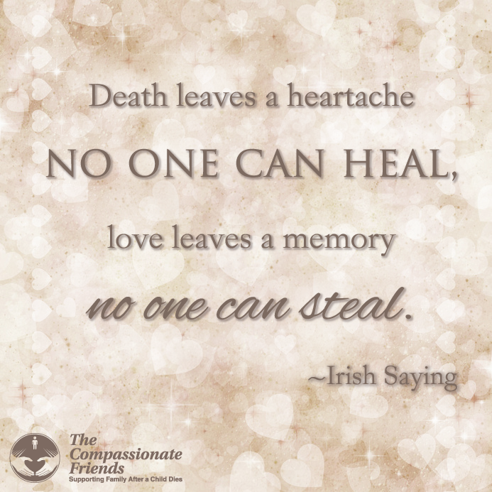 Communion
On the first anniversary of your death,
I went to the kitchen,
set the table with your Superman placemat
and pulled up your chair.
I made a peanut butter and jelly sandwich,
and removed the crust as always
for a special occasion.
I cut it into quarters and arranged the triangles on your red plate.
I poured milk in your blue plastic
Crayola crayon mug, put on its pointed top
with the hole in the tip for a straw.
I had no straws. I don’t buy them anymore.
Sitting next to your place,
I apologized for no straw.
I apologized for your death.
I apologized for not being there.
When I finished,
I wiped my eyes with your napkin,
gave thanks, ate the bread
and drank the milk.
--Shelley Wagner,
The Andrew Poems
First Anniversary
A year has come and gone since I held you in my arms, the day you died. It seems like a blink of an eye on the one hand and an eternity on the other. Many people thought of you on this day. Some were able to share their sadness with me and we shed tears together. Others didn’t want to upset me, so they didn’t mention your name. How can anyone believe that I don’t think about you unless they say your name? I guess that people don’t really understand the constant emptiness I feel without you, or the good feeling I get when someone lets me know that they remember you.
I wish I could say to friends & family:
When you see me crying at the mention of Ali’s name, they are tears of pain and an expression of grief. I must cry in order to heal. Please make it comfortable for me to express my feelings so that I can progress through my grief.
The steps I am taking are baby steps. Please don’t expect me to return to normal just because a year has passed since my daughter’s death. The fact is that I’ll never be the person I was before this terrible tragedy occurred. I’m a different person now. Please be patient with me because I don’t know the new me yet.
I will never forget my daughter or the joy and love she brought to my life. It helps me to know that others remember her too. Please share your memories with me so that Ali may live for a few moments as you saw her.
There are no shortcuts through grief. Please don’t push me. I need to feel and experience my grief without a set time-table, without expectations I cannot live up to. I know you care & are concerned, but you can’t take this pain from me the way you would like to. I do need you for support and acceptance.
This is the first of many anniversaries. I can’t imagine the pain lessening, although many say it does. I just know I made it through the first of everything without Allison, and I am beginning the second year, wounded but alive.
--Grace Kuther, TCF Manhattan
Two Years Later
It has been two years, and it seems like yesterday. The pain is two years older, but still the same; the tears are two years older, but still the same. Will it be three times worse next year, or four times worse the next? I don’t know.
Bradley is two years older and will not remember you, except for the things I can tell him. I sit him on the counter next to the refrigerator, and he looks at the pictures I have on it of him and his big brother. I explain to him that he was only two when you were killed. He won’t remember how you used to tape leaves from the trees on the door to your room, so he wouldn’t get into your things. He was so afraid of the leaves when they would blow in the yard.
He won’t remember going with us to get your learner’s license, running around wanting cookies and something to drink, distracting you from your test. He was so funny, and you were standing there rolling your eyes at him. He won’t remember riding in the front seat while you drove home, with me in the back. I was so proud. He won’t remember his two short years with you, but he’ll know —I promise.
--Marilyn Baker, TCF Atlanta
I’m Still Counting
My son’s favorite character on Sesame Street was The Count. Todd would laugh and count and laugh some more whenever The Count would appear on PBS. “Come on, Mom,” he would say, “Count with
me.” So, I would join him, and we’d count together. When my child died, I started counting hours. One hour since he died, two hours, then 24 hours, 36 hours, 96 hours. I started counting weeks, then months and finally years. I was totally focused on the moment that my son left this earth.
Now I count the years and months, weeks and days. While this may not sound like progress, it truly is a step back into life. Three years, seven months, one week and one day. I stopped adding the hours. Moreover, when people ask me about it, I generally say about 3½ years. I try to keep it simple for outsiders who can’t begin to understand.
Every month I dread the 19th. Another month is added to the time between my son’s last breath and now. It’s almost as if time might separate us, erase him from the memory of those who knew and loved him.
Despite my obsession with counting, I am moving forward in many ways. I think of my child each day. I honor his life each day, and I feel a real apprehension about his daughters each day. Their lives are horribly different from what they might have been if Todd had lived.…
I know I cannot change this. So along with my private obsession, there is a deep lingering sadness for my son’s children and for opportunities lost. In the meantime, I count years, months and days. I keep my unconditional love for my child in my heart and in my life. And I continue to reach out and become the person I am meant to be. And I’m still counting with Todd.
--Annette Mennen Baldwin,
TCF Katy, TX

Bereavement
Balance Beam
Notice the athlete as she carefully
and gracefully strolls across
the balance beams.
She makes it look so easy.
We watch and hold our breath,
hoping she won’t fall.
She artistically swivels at the end,
goes back to the middle,
and without missing a beat,
lands perfectly on the mat below.
I am not an athlete, nor an acrobat,
yet I walk a balance beam every day.
I tread gingerly across the beam;
I know you haven’t noticed.
I hold my breath, not as a spectator,
but as a participant.
I wear an outfit not of spandex
nor sweats, but of steel-plated armor guarding my emotions.
I give a presentation of poise and control, which I’ve learned
with each step I’ve taken.
I know how to survive,
take each day one step at a time,
sometimes pausing for laughter,
sometimes trembling with tears.
Then there were the times I fell off,
which in the beginning took but a mere reminder of what I’ve lost.
And I toppled off the balance beam only to struggle silently
to climb back on.
What caused the fall?
--Perhaps a mention of his name,
--perhaps hearing his favorite song,
--seeing a young boy on a bicycle
and knowing it wasn’t James,
--seeing a mom at the store shopping
for back-to-school items,
--reminiscing about bedtime stories
which are now no longer told,
--watching someone else’s child
at the soccer fields,
--driving in the car alone with no one
next to me in the passenger seat.
But I learned to stay on
the balance beam,
handle those moments of pain and loss,
keep my composure, let the tears fall,
but let not my steps falter.
Turn the corner without tripping,
keep life in balance and in perspective
with a huge void on the other side.
Now, almost five years later,
I’ve nearly perfected this trick.
Can’t compete with a professional athlete.
They have the physical, visible aspect
of this performance down pat.
I’m still working on the emotional,
mental portion but doing quite well.
Till I hear my young niece
gets to be a mom,
--or my sister-in-law moans
that her son is away for a week
and the house is so quiet,
--or yet another friend
has become a grandmother,
--someone else we know
is graduating or marrying,
--my nephew turns 16 and gets a license,
--all the reminders of who I’m missing:
what James never will accomplish,
the opportunities
that James missed out on,
the life I wish I could see James
experience and be a part of.
It’s all a matter of balance,
keeping the stride,
maintaining a sense of normalcy,
balancing, in spite of a broken heart
and an emotional handicap.
And learning that when falling below,
there are friends to help me back up,
memories to give me smiles,
determination to live the life
James would have wanted…
for both of us.
--Meg Avery, TCF Winnett
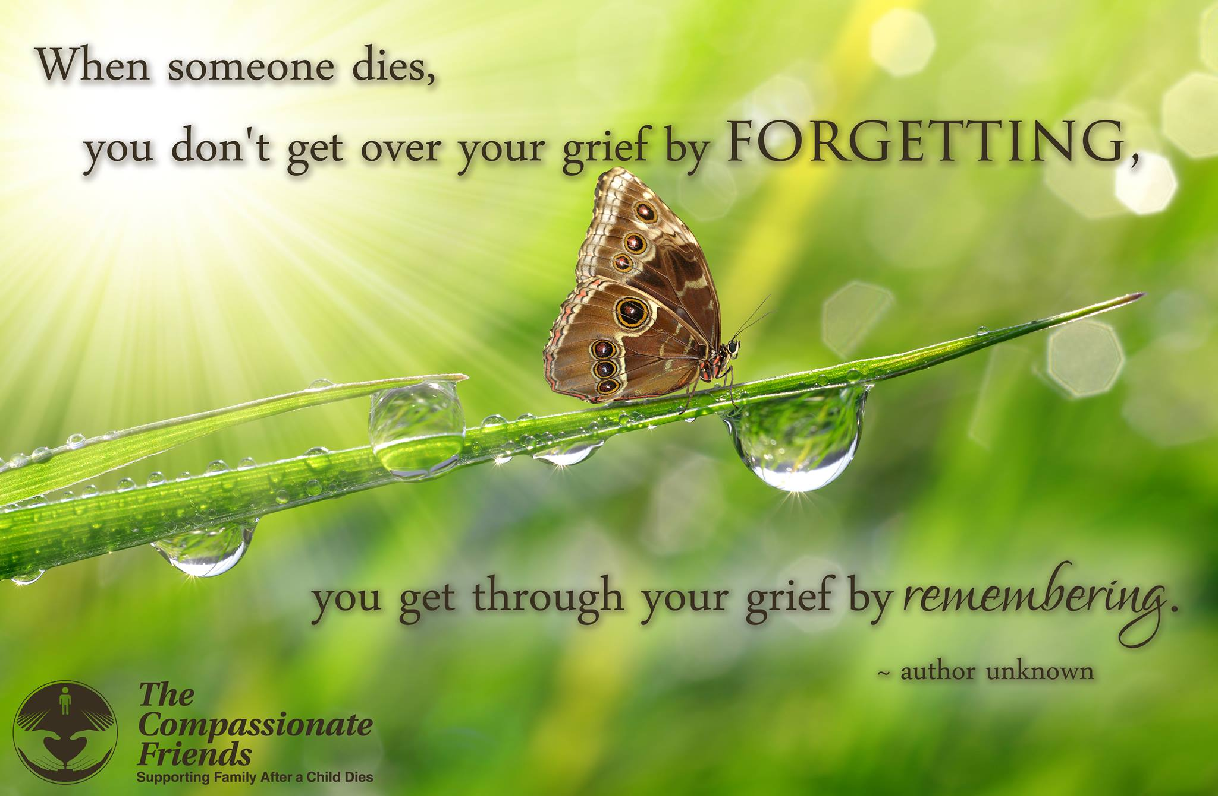

Ten Years of Lessons
from the Heart
It seems impossible that it’s been ten years since my two oldest children—21-year-old Denis and 19-year-old Peggy—were killed in the same car accident! Peggy died instantly and four days later, the day after we buried her, Denis died. In one week, we planned two funerals, proclaiming to the world how much we loved them and how unique each was! Now, looking at their pictures and reminiscing, I ask myself what the past ten years have taught me, and I must admit that it’s been a lot!
My life has changed, my family tapestry has been rewoven. Different routines and traditions have been established, and new celebrations, friendships and interests have been developed. I have discovered the things that ease my heart and allow me to breathe without feeling that excruciating pain from losing someone dearly loved.
In the early days of my grief, all I wanted to know was, how do I survive? In an effort to learn, I read everything I could get my hands on. I ran to the public library, the bookstores, searching their shelves for words that would soothe my pain, reading the heart-felt prose and poetry of all those bereaved persons before me. That is how I first heard of The Compassionate Friends, which later became such an integral part of my life. Story after story touched my heart and gave me guidelines for surviving.
On Sundays I reverently took my favorite paperbacks to church and read their comforting phrases, cover to cover, as the priest and congregation worshipped around me. Anything that moved me and gave me a consoling thought, I memorized and shared with my husband Joe and my daughter Annie. Reading was my first step to recovery in those dark beginning days, pulling me out of the depths and filling me with positive thoughts to get through a day.
To conquer the utter exhaustion that assaulted my body (a big component of the grief process), I learned to rearrange my activities and to carefully pick and choose those things that would not be overwhelming and might even bring some enjoyment. Simplifying chores and cutting plans into shortened hours made it possible for me to make a list of things I could handle and rescue me from defeat. As I got stronger, I was able to include more activities and to increase the time I spent on them.
--Elaine Stillwell
At first
my very name was grief.
My thoughts were grief
and everything I touched
was turned to grief.
But now
I own the light of memories.
My eyes can see you,
and my thoughts can know you
for what you really are:
more than a young life lost,
more than a radiance
gone into night.
Today you have become
a gift beyond my grief,
a treasure to my world
though you have left
my world and me behind.
--Sascha Wagner, Wintersun
Layers
I can’t believe the number
of layers to this grief!
it’s really never ending!
Please let me find relief!
But wait—that really isn’t
the truth what I just said
All I really want is
for him to not be dead!
Each layer is so different
as each one peels away
And I find myself asking
How much more can I take?
I thank God for compassion
and love that I have found
And hate Him for the fact that
my son is not around
I know that he is happy
I know that he’s okay
I know he keeps in touch with me
and loves me every day
The pain I live with daily
so deep down in my soul
Is how much it has cost me
for having loved him so
But I know I would never
want him to not have been
so, I could maybe skip this
heartache I feel within
I know I’d never give up
The love he brought to me
My world got so much brighter
The day he came to be!
By Jenny Donaldson, South Kansas City TCF chapter
My God, has it been ten years?
Oh, parents of Littleton, our hearts went out to you. Their faces, so young, so fresh, like the early morning dew. Their plans, their hopes, their dreams evaporated before your eyes. We knew you wouldn’t find answers to the many, many whys. Our hearts went out to you, as your tear-drops gushed like rain falling from saddened, swollen eyes, flooding the river of your pain. We prayed for your comfort and peace, through the endless days of mourning and despair, and still pray you have been able to rise from the ashes, to go on for those you hold dear.
--Based on the words of Joyce Margarce, TCF Katy, Texas. The Columbine High School shootings were April 20, 1999.

An Elegy to Dan
Pounding on the door late at night,
a policeman brings us the message.
The car moves maddeningly slow.
Will we ever get there? …
The wait seems long.
We sit huddled in that cold corridor,
refusing to understand, each pretending.…
word comes, sister cries, pastor prays.
I demand to see my son,
waiting at the emergency door.…
finally, they roll him out.
Even then my heart swells with pride.
I place my hand on his beardless cheek,
already turning cold. “Oh Dan,” I say.…
Sister’s tears fall on his forehead.
We leave. No one speaks.…
There’s activity in the street.
People are going to work.
My God, people are going to work!
--Elnora McConnell Borden, TCF Atlanta

Roadside Crosses
Everyone has their own cross to bear,
and sometimes it’s an invisible load.
But our cross is visible for all to see
as it stands by the side of the road.
We’ve carried our cross for four long years
and we will often stop by for a prayer,
Something that never entered our minds
when our spot by the roadside was bare.
Now as we travel this long weary road
sometimes we will spy a new cross.
We now know the hurt that cross represents,
and the deep and unbearable loss.
Yes, our crosses may be all weathered
and worn and slowly falling apart.
But our crosses simply mirror the images of
reflections found deep in our hearts.
--Linda McInturff, TCF, Southern MD
My Secret
Within days of my son’s tragic death in a helicopter crash, it became my sad duty to remove his belongings from his apartment. In the numbing fog of shock and denial, I sifted through the contents of every drawer, cabinet and closet. The wrenching decisions of what to do with his clothes, his video tapes—even his toothbrush—made my head swim. Although I gave many of his things to his roommate, other friends, family and “Goodwill,” I kept the “special” things for myself—school yearbooks, pictures, and certain items of clothing and his collection of crazy T-shirts. I put this strange assortment of things in his footlocker, a remnant of his boarding school days.
What I didn’t tell anyone was that I never laundered the T-shirts I found in the dirty clothes hamper. I just folded them and put them in the foot locker with my other memories. And from time to time during those first months of agonizing pain, I sat on the floor and opened the treasured remnants of a life that had been such a large part of mine. Then I would take the unwashed tee shirts and bury my face in them, inhaling the combined scents of his cologne, deodorant and perspiration, mixed with the wetness of my tears. It made me feel for just a moment that he wasn’t really so far away. “What a perverse thing to do,” I thought. “I’m sure no one else would ever understand my doing such a thing—surely they’d think I had gone off the deep end.” So, I never told anyone about this strange behavior—and the odd comfort it gave me.
Months later at a national TCF conference, I heard a speaker tell hundreds of bereaved parents assembled about a mother whose baby had died suddenly and how she refused to wash the soiled shirt the infant was wearing but found comfort in holding it close to her and smelling it. “My gosh,” I thought, “maybe I’m not so crazy after all.”
Since this experience I have discovered that it’s not as uncommon as I had thought. The scents of a loved one are as much a part of them as the sound of a voice, the touch of a hand or the tenderness of a kiss. There is nothing “perverse” in wanting to cling to those precious memories. If it were not for The Compassionate Friends, I might never have known that my actions, rather than strange, were perfectly normal. Another example of the many ways TCF can help us through this difficult journey.
--Carol Ragland, TCF, Houston-West Texas

The Children of April 19th
Let these children forever remind us
that our souls may be
in greater peril than theirs.
Let these children forever remind us
that we are the ones
who need their blessings now?
Let these children remind us to pray,
that time has not run out for us.
--Sascha Wagner in “Wintersun”
The Oklahoma City Federal Building bombing occurred on April 19, 1995.

Believe
Believe.
Crocuses poke their heads
through the crusty snow
to let us know
the long, bleak winter is ending
and Spring will come again.
So, too, the long bleak winter of
your aching, breaking heart will end
and spring will come again one day.
Be patient—but believe it—
Your spring will come again.
--Betty Stevens, TCF Baltimore, MD

Ode to Endurance
several years since you left
you’d think my heart would heal
seven years – science tells us
it takes for our whole body to renew
all molecules regenerated
so I think I should be ready
to let go of you
but the hole
in my soul
persists
--Lynn Marti Avant, Ames Iowa

Thoughts for Springtime
Would it be easier,
If spring were not so lovely?
Would it be easier,
If robins did not sing?
Would I be stronger,
If the trees were barren
Or if a cloak of gray hid everything?
Could I be braver,
If the days were faded and
If the sun remained remote and cold?
I hear the whispers of a new beginning.
The earth is new,
Why is my grief so old?
--Sascha Wagner

Love Never Goes Away
“Why does it hurt so much? Why is this grief so incapacitating? If only the hurt weren’t so crushing.” Sounds familiar? All of us have known hurts before, but none of our previous “ouches” can compare with the hurt we feel. Nothing can touch the pain of burying a child.
Yet most of us have discovered that the sun still comes up. We still have to function. We did not die when our child died, even though we wish we could have, so…we are stuck with this pain, this grief. What do we do with it? Surely, we can’t live like THIS forever! There are no magic formulas for surviving grief. There are a few recognized patterns for grief, but even those are only guidelines. What we do know is that the emptiness will never go away. It will become tolerable and livable…someday.
TIME…the longest word in our grief. We used to measure TIME by the steps of our child …the first word, first tooth, first date, first car.…Now we don’t have that measure anymore. All we have is TIME, and it only seems to make the hurt worse. So, what do we do? Give ourselves TIME…to hurt, to grieve, to cry. TIME to choke, to scream. TIME to be “crazy,” TIME to remember.
Be nice to yourself! Don’t measure your progress through grief against anyone else’s. Be your own timekeeper. Don’t push. Eventually, you will find the hours and days of grief have turned to minutes and then moments…but don’t expect them to go away. You will always hurt. You don’t get over grief…it only becomes tolerable and livable.
Change your focus a bit. Instead of dwelling on how much you lost, try thinking of how much you had. Try letting good memories come over you as easily as the awful ones do. We didn’t lose our child…HE/SHE DIED. We don’t lose the love that flowed between us…it still flows, but differently now.
Does it help to know that if we didn’t love so very much, it would not hurt so badly? Grief is the price we pay for love. And as much as it hurts, I’m very glad I loved. Don’t let death cast ugly shadows, but rather warm memories of the loving times you shared. Even though death comes, love never goes away
--Darcie D. Sims

Time does not touch
the firmament of stars
with a simplicity
of days and nights and years.
The rhythm of this smallness
we call earth
is only a whisper among galaxies.
Beyond the measured years which
rise and fall beyond the calendars
of human time and place,
the meaning of this smallness
we call life will find us
somewhere in eternity.
“For You From Sascha”by Sascha Wagner
Sorrow
It hurts deep down inside.
One feels diminished,
less than we have been.
Empty, bereft –
forlorn and incomplete.
Sorrow is a painful word,
but if someone is there
to share the feeling,
it becomes endurable
and in the scheme of things
a time of being
that includes great emotion
and thus, a time of closeness,
growing and becoming someone
more than we have been before.
--Shirley Holzer Jeffrey, “Louie” chapter,
in Death: The Final Stage of Growth
by Elisabeth Kubler Ross
Healing…Unobserved
I used to wonder why I always felt like crying when leaving a support group. Then one night I left, and it felt as though a great load had been lifted from my inner being. For the first time in several years my surroundings came alive. I observed the twinkling of stars and brightness of the moon. I heard the crunching of snow beneath my boots and paused to watch a rabbit darting to and fro in the twilight. Is this the beginning of healing or has it been there—slowly and desperately with great persistence—trying to emerge from beneath the greatest of sorrows and pain? Maybe tomorrow…I will make a snow angel!
--Nancy A Gleim,“From the Heart of Samantha”

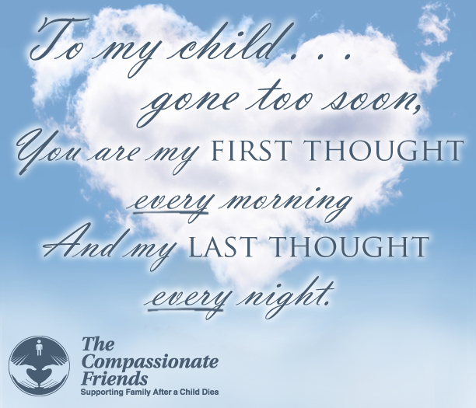

Beannacht (Blessing)
On the day when the weight
deadens on your shoulders
and you stumble,
may the clay dance to balance you.
And when your eyes freeze
behind the grey window
and the ghost of loss gets in to you, may a flock of colors,
indigo, red, green, and azure blue
come to awaken in you
a meadow of delight.
When the canvas frays
in the currach of thought
and a stain of ocean
blackens beneath you,
may there come across the waters
a path of yellow moonlight
to bring you safely home
May the nourishment
of the earth be yours,
may the clarity of light be yours,
may the fluency of the ocean
be yours,
may the protection of
the ancestors be yours.
And so, may a slow
wind work these words
of love around you,
an invisible cloak
to mind your life.
--From Echoes of Memory by poet John Donahue (1954-2008)

“Watch diligently…
for each day comes
bearing its own gifts,
but you must untie the ribbons.”

Not An Easy Word
Hope is not an easy word for grievers—
but we, more than most others,
need to understand
what hope can mean for us.
Hope means finding the strength
to live with grief.
Hope means nurturing with grace
the joy of remembrance.
Hope means embracing
with tenderness and pride
our own life and the gifts left to us
by those we have lost.
--Sascha Wagner
__________________________________
The most beautiful people
we have known are those
who have known defeat,
known suffering, known struggle,
known loss,
and have found their way
out of the depths.
These persons have an appreciation,
a sensitivity and an understanding
of life that fills them
with compassion, gentleness,
and a deep loving concern.
Beautiful people do not just happen.
--Elisabeth Kubler-Ross

A Different Love
When I first knew you
You grew in my womb.
Then we shared your sweet life
for a year.
Now I’m learning to know you again
as you grow in my heart,
and I’ll share my life with you
for eternity.
--Maggie Knight



Please help us help others. Make a LOVE GIFT today. Tax deductible Love Gifts may be sent to: TCF C/O Carol Cavin 214 E Hansen Ct, Independence, MO 64055

UpCOMING EVENT:

41ST TCF NATIONAL CONFERENCE

JULY 27 - JULY 29
INCLUDEPICTURE "https://www.compassionatefriends.org/wp-content/uploads/2017/10/2018-Conference-Logo-event-image.jpg" \* MERGEFORMATINET INCLUDEPICTURE "https://www.compassionatefriends.org/wp-content/uploads/2017/10/2018-Conference-Logo-event-image.jpg" \* MERGEFORMATINET INCLUDEPICTURE "https://www.compassionatefriends.org/wp-content/uploads/2017/10/2018-Conference-Logo-event-image.jpg" \* MERGEFORMATINET 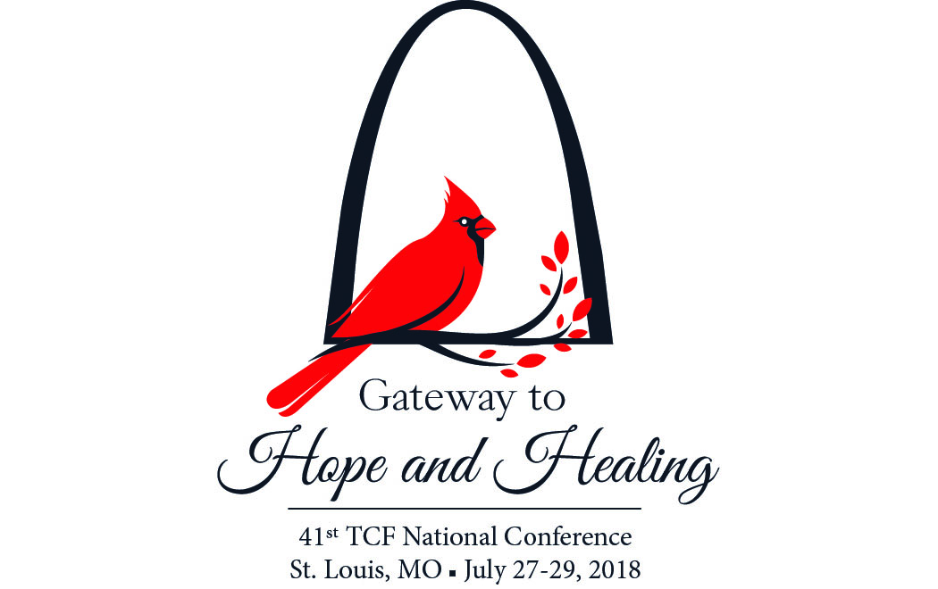
The Compassionate Friends is pleased to announce that St. Louis, Missouri, will be the site of the 41st TCF National Conference on July 27-29, 2018. “Gateway to Hope and Healing” is the theme of next year’s event, which promises more of this year’s great National Conference experience. The 2018 Conference will be held at the Marriott St. Louis Grand Hotel. To register for the event and Hotel registration go to the National website wwww.compassionatefriends.org, our website at www.easternjacksoncountytcf.org as well as on our chapter TCF Facebook page and TCF/USA Facebook Page and elsewhere as they become available. Plan to come and be a part of this heartwarming experience.

For Remembrance dates please visit our website at www.easternjacksoncountytcf.org
Find us on Facebook at https://www.facebook.com/groups/1582699755290182
We have several volunteers who write remembrance cards to families on birthdays and death dates. Just a reminder if you have an address change please email phillipsplace@aol.com or mail a note to TCF, C/O Theresa Phillips 6200 Kentucky Raytown, MO 64133 so the roster can be updated.
Please remember that you can give to The Compassionate Friends through your United Way pledge at work or as a single gift, but you MUST WRITE IT IN.

