 Jan.-Feb 2016
Chapter Leader: Theresa Phillips TCF National Headquarters

24-Hour Help Line: (816)941-3904 PO Box 3696, Oak Brook, IL 60522
Private Facebook Page: Eastern Jackson County TCF Website: www.compassionatefriends.org
Website: www.easternjacksoncounty tcf.org 630-990-0010

This Can Be a Constructive,
if not a Happy Year
HAPPY NEW YEAR??? “How can it ever be again?” “How will I ever make it through another year of this torment?”
When we are hurting and so terribly depressed, it is hard to see any good in our new year, but we must try. First, we must hold on tightly to the idea that we will not always be this miserable, that we will some day feel good again. This is almost impossible to believe, but even if we don’t believe, we must say it to our-selves over and over again that IT IS TRUE, BECAUSE IT IS! Many parents whose children have died in the past will attest to this. Remember, no one can suffer indefinitely as you are now.
Second, we must face the new year with the knowledge that this year offers us CHOICE—whether we will be on our way to healing this time next year or still be in the pit of intense grief. We must re-mind ourselves that if we choose to be on our way to healing by the following year, we must work to get there and that work entails allowing ourselves to go through our grief, to cry, to be angry, to talk about our guilt, to do whatever is necessary to move towards healing.
Third, we must look for good in our lives and find reasons to go on and accept the fact that our continued suffering will not bring our child back. Many of us have other children and a spouse for whom we must go on. More important, we have our own lives that must be lived. Most of us know that our dead children would want us to go on!
No, this coming year may not be a happy one, but it can be a constructive one. Through our grief we can grow and become more understanding, loving, compassionate, and aware of the real values in life. Let us not waste this new year!!
--Margaret H. Gerner,TCF St. Louis, MO
January One
New Year
new life
new hope
new expectations
new beginnings
Old times
old fears
old places
old disappointments
old dead ends
I am aware
of my resistance to change
I am aware
of how reality is and how
Life Goes On
I am aware
of how I feel vulnerable
Birthdays
Death days
Celebrations
Anniversaries
Seeking a new future
as the haunting past returns
I AM ME
Change is possible and difficult
inevitable
I LIVE ON.
NOW
--Cindy Bouman, TCF, Hinsdale, IL
The New Year comes when all the world is ready for changes, resolutions...
great beginnings.
For us, to whom the stroke of midnight means a missing child remembered,
for us the New Year comes
more like another darkness.
But let us not forget that this may be
the year when love & hope & courage
find each other
somewhere in the darkness

to lift their voices and speak:
Let there be light.
--Sascha Wagner

After the Holidays
The holidays are hard on all of us, but the let-down after seems to halt our grief work. As bad as the holidays are, they are filled with people and noise, some laughter and tears. In general, you have to roll with the activity of the larger family.
It’s quiet now. It would be a good time to “reach out and touch someone.” Maybe with a call or maybe with an old-fashioned handmade Valentine. Think of the people around you that have helped you make it to the place you are today, and let them know they’ve helped you. It is easier to write and mail kind words than it is to say them face to face. If that just isn’t your style, spend some time at the card shop; search out the sentiment that best reveals your inner feelings about your spouse, your children, your relatives or your friends.
We spend so much time indoors these cold winter days, it’s easy to allow ourselves to crawl into an inner shell. Make an effort to come out of yourself. Go to the next TCF meeting with something to share: a card you’ve received or copy the verse of a card you chose to send to a loved one. Or try to write and decorate a card to your missing child. Prepare for Valentine’s Day by binding the lovely cards of past years from your special child. It may take courage to re-read them, and it may bring tears to your eyes, but maybe it will bring a little joy to your soul to remember how innocently and sincerely they loved you. Some of us have no card from our special children, but we know the special love of “Cupid, the Angel’s Arrow.” Our hearts have been pierced too.

--Anne Misel, TCF, Niles, OH

Silk Roses for Susan
I took silk roses to your grave today.
Valentine’s Day is coming
and you loved red roses.
I sat there awhile and remembered your last Valentine’s Day.
I kissed you and gave you candy
with money stuck in the top.
You tilted your head
in that certain way you had
and smiled, pleased at the gift.
Sweet daughter, I miss you so.
There was still much of life to share.
Nineteen is way too young for dying.
I would buy fresh roses for you every day if I could have you back.
But I can’t change the ending.
So I took silk roses to your grave today,
and cried fresh tears instead.
--Ginger Elwood, TCF, Knoxville, TN

A Valentine Waiting for You
There’s a valentine waiting for you
That’s different from all the others.
It’s there every month at our meetings
For fathers, mothers, sisters & brothers.
Its envelope is made of caring.
The glue of understanding seals it tight.
This non-judgmental group
who’ve been there
Help to take away your fear and fright.
So come join with us together.
Read your loving message printed clear,
In not only this month’s Valentine,
But all those throughout the year.
--Mary Cleckley, Atlanta, GA

we who were left behind
to know the shadows
we who were left behind
to touch the night
we who were left behind
to heal the darkness and
to share this day
we who have turned once more
to hope and loving
though we were given graves
and lifeless children--
we hear them now
these children and their song
reminding us
reminding us again
that we must fill the time
we spend in life
with understanding
tenderness and peace
–Sascha Wagner

It Is Time for Love
February has fewer days than most months, and that may be of special significance to us, as our children had fewer days than most. When we think of this month, the most outstanding day, perhaps, is St. Valentine’s Day. It is a time for love.
When we were school age we had a special chance to give and receive cards in those decorated boxes in our primary classrooms. Perhaps it is the one holiday when children can really do something for everyone. Addressing a card to each and every classmate made you think of how you felt about each one and wonder about how they felt about you.
Love is found in every day of every year, but February and Valentine’s Day are very special. I wish I could remember just how it felt to get a “nicer”
Valentine from someone I sent a “nicer” one to. It is so long ago, and there have been so many, much more significant happenings in my life. But sometimes, I’d like to remember just how it felt. I am sending along this Valentine Love Note to each of you right now and hope that you know it is one of the “nicer” ones, because each of you is very special to me. Somehow I don’t wonder how you feel— I know.
As we grieve the loss of our children and one another’s, we begin to find a different kind of love than we ever expected to experience.
--Rosalie Baker, TCF Rochester, NY

I Will Love You
As long as I can dream,
As long as I can think,
As long as I have a memory...
I will love you.
As long as I have eyes to see,
and ears to hear,
and lips to speak...
I will love you.
As long as I have a heart to feel,
a soul stirring within me,
An imagination to hold you...
I will love you.
As long as there is time,
As long as there is love,
As long as I have a breath
to speak your name...
Because I love you
more than anything...
In all the world.
--Daniel Haughian, Coeur d’Alene TCF

Heart Room
When I first measured my heart,
I could not see; the light was dim.
A friend held the lamp while I looked in.
There was room for another person’s
pain and sorrow,
And plenty of room for other people’s tears.
The depth of my compassion
everyone could see.
But none of it really mattered until
There was room in my heart for me
--P. G. White

The Season of the Heart
This is the Season of the Heart! Yet many of us will be asking how to live during this season with a heart that is broken. What is it that our hearts know during these days? What are the feelings that pulsate and ebb and flow? Is it:
- The Heart that catches its breath on a memory and is overwhelmed?
- The Heart where hope seems absent?
- The Heart that feels it absolutely cannot hold one more ounce of pain?
- The Heart that knows the fleeting smile of a loved one?
- The Heart that catches a fragment of joy and is warmed?
- The Heart that knows pain, and keeps on loving?
- The Heart that is tempted to lie still and lonely?
- The Heart that searches for the acceptance of a friend?
- The Heart that is one day, suddenly, surprisingly single?
Questions arise! Why is a heart red?
Why does it have two lobes?
- A heart is so vulnerable, so easily bloodied.
- A Heart consists of opposites, changed by sorrow and by joy.
- A Heart, when whole, includes all emotions.
- A Heart can lie cold & sad & broken
- A Heart can grow and heal and love…
We each have our choices to make!
--Marie Andrews, Southern Maryland TCF

It’s Grief to Me
It has been stated that our entire life is summoned up in the dash between the date of birth and date of death on our tombstone. Life will bring death. Death will bring grief, an active, vio-lent emotion that lives and breathes in one’s life for days, weeks, months, and sometimes years. Listen to what grief has to say.
“I wait my turn patiently, through births, accidents, illnesses; but sooner or later I will visit you. I will come like a thief in the night: a knock at the door, the ringing of a phone, perhaps even a letter. At first you will not acknowledge me. You will deny me, avoid me, run from me, but rest assured I will become your unwanted guest. In time I will feel like a friend.
“At first I will feel like a wave of emotion like none ever experienced before. You will weep, you will feel intense anger, you will be physically sick and become unbalanced and some-times literally lose your sense of being. Friends, at first, will spend much time with you. They are relieved it is you feeling this pain and not them. It’s their duty to offer you a shoulder to cry on, a pan of lasagna, and several cards. But their lives have not been disturbed and they will leave your house without me.
“As the days pass, everyone around you has gone back to being normal. They haven’t forgotten you, but they have either not experienced me or have forgotten me. You, on the other hand, are walking in a fine fog of my making. If you think, I will be there. If you run from me, I will be waiting. Your days are spent trying to act normal and your nights are spent alone with me. I can produce memories from the past that even you had forgotten. These memor-ies are meant to dredge up even more painful memories. Not that these mem-ories are bad, but they are so poignant that you will feel as if your heart will break. It is I who will determine when I leave. You cannot rush me or push me away. The deeper your love, the longer I will linger.
“As I begin to weaken and start the process of leaving, you may at first become frightened. You will fear that you are not being true to your loved one or will forget. Sometimes this fear will strengthen me and I will linger longer. At other times, I know it is time for me to spend time with someone else. It is time for you, my friend, now, to move on.”
--Julie M. Beasley, Mechanicsville, VA, in Bereavement Magazine, Sept./Oct.r 2003. www.bereavementmag.com
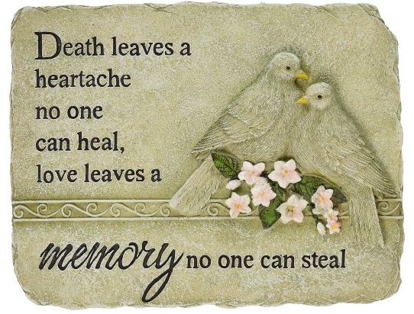
We Are Survivors
In the beginning we are survivors
groping and clawing merely to rise
& face each day without our children
WITHOUT OUR CHILDREN
But emotionally we cannot
(nor should we)
come to terms with this reality.
One cannot make this emotional commitment called parenting, then
abruptly shut it off after a funeral
whether our child was six months or 60.
Our love, our sacrifice, our future
cannot be measured by a
chronological clock.
Thus we cling to the hope that this is a
bad dream, a mistake, that soon
there will be a knock at the door,
the phone will ring,
we’ll hear their footsteps upstairs and
they will be back where they belong
BACK WHERE THEY BELONG
In the beginning we face each day
with disbelief. We plod on,
but we want our children back
not their pictures, not their clothes
not their memories
WE WANT OUR CHILDREN BACK
As weeks turn into months,
months into years, our lives start to
“normalize” (although
we will never be the same again).
Emotions begin to
catch up with intellect
we gradually, grudgingly
come to realize that they are never coming back to the way they were
(we seek out psychics to connect
with them where they are now)
As parents we have
the need to nurture
(I will ALWAYS be your parent,
you will ALWAYS be my child).
We are compelled to make an
emotional compromise and
keep them alive in different ways.
Like the caterpillar
transforming into a butterfly
our children take on new lives.
To be sure it is not the way
we want it to be
but now in our hearts
and in our heads we say
“this is the way it is,
this is the way it is going to be.”
Now we are parents again
and they are our children.
we have paid the ultimate price
for wisdom, strength and courage
and though we will never
be the same again
we will BE
--Phyllis & Moe Beres, TCF, Babylon, NY

Because of you,
I love a little more,
Because of you I take time
To give an extra kiss
good-bye.
Because of you,
there may be dust
On the window sill,
and I don’t care.
Because of you, I live today,
Before I worry about tomorrow.
Because of you,
I don’t give up quite as fast.
Because of you,
now I can help or
listen more.
Because of you,
today, I am ME.



The Promise of Spring
When February comes, there is finally an end in sight to the long winter. Sometimes melting snow reveals the green tips of an early crocus or even the exquisite blossom itself, a soft flower of hope invading a harsh landscape of graying snow and biting wind and ominous sky--a small promise of new life to come.
My heart, grieving for my son who died, was like that image of winter. For somehow, even during the darkest, coldest mo-ments, an unexpected sign of hope would intrude. And as the hours and days and months dragged on, my heart finally learned once again to be open to the promise of new life. Painful mem-ories melted into loving ones. Life that seemed forever dormant once again sprang forth from my heart.
In living hopefully and lovingly, the season of the heart can change. The loving memories of your child, like the flower in the snow, can be the beginning of the end of winter.
--Maryann Kramer, Arlington Heights, IL, TCF

The Bulldog Shirt and Chris
Not long before I lost you, you came over one day with this shirt. It was big and gray and it had a Georgetown University Bulldog emblem on it. You were tall and lean, but you always wore your clothes too big and this shirt was no exception. It was a big man’s shirt with a tough-looking bulldog on the front of it. It was definitely not a shirt I would have picked out for myself, but you wanted me to keep it and wear it. I didn’t understand why, but I wore it.
At the time you gave it to me, I had no idea what this big, bulldog shirt would come to mean. This shirt quickly became my favorite shirt; it goes with a pair of jeans and I wear it when I go out for breakfast, when I’m relaxing around the house watching television, and I also wear it to sleep in.
After you left me, this shirt became much more than a com-fortable shirt to wear. It became my special memory of you. I wore this shirt so much and washed it so many times that it has acquired many holes, and every time I pull it out of my drawer to wear, I vow that it will be the last time. I need to put it away and preserve it for a special keepsake to hold and treasure forever and ever.
But that’s not why you gave it to me. You wanted me wear it and each time I do, I think of you. I just can’t put this shirt away, just like I can’t let my memories of you ever be put away.
I remember asking you why you wanted me to wear this shirt. I said, “Chris, it fits you so much better than it fits me.” You said, “Momma, I just want you to have it and wear it.”
So, honey, I did, and I still do. If you only knew how many times I have worn that shirt and how many times I have held it in my arms and cried over losing you.
Well, Chris, I still find comfort whenever I put that shirt on. And I know in my heart that soon, very soon, I will have to put it away in a plastic bag in order to keep it. If I continue washing it and wearing it, I will lose it. This way, if I put it away in a plastic bag, I will be able to get out that old bulldog shirt when I’m feeling lost, sad and lonely. And I can remember the comfort of your long skinny arms wrapped tightly around me. Maybe it will even wipe the tears from my eyes. I will always love you, Chris. Love, Moma
--In memory of Christopher Alan Carter (7/21/77 - 2/12/94)
by Denise Vicic, Chris’ Mom, TCF of South Central Kentucky

--Daniel Haughian, Coeur d’Alene Chapter TCF

Ten Tricks Your Brain Plays on you During Grief
Your brain-what an amazing organ. It can outthink the most complex computer. It is-well-it's who you are. Your brain-or you-is reading these words and taking in information in microseconds. So, with all its wondrous abilities, why would your brain trick you, especially at a time when you need it most? Because it's not perfect. However, don't let your brain (or you) take it personally. Just keep reading and you'll begin to recognize how these brain imperfections can influence you during the most difficult time of your life.

Trick #1: I will feel this way forever.
When the death occurred, you absolutely believed that you would never laugh again; but you did. Do you remember that first time? Were you surprised when you heard laughter and realized that it was coming from you? After you recovered from the shock, you may have chastised yourself for "forgetting" your loved one. As time has gone by, however, you have hopefully begun to realize that your loved one would want laughter to return.

Trick #2: Guilt
Perhaps the cruelest trick your brain plays on you is one where the past continues to be rewritten. Just look at all the ways that guilt can complicate your grief. See if any of these sound familiar:
If-Only Guilt-After the death you find yourself revisiting events in the life of your loved one in which you say, "If only...." Or "I should have...." or "Why didn't I?"
Role Guilt-"I wasn't a good enough __________________ to this person." We're still waiting for the perfect (choose one) parent/spouse/sibling/grandparent/child.
Death Causation Guilt-The death occurred because of something I did or failed to do. It matters little whether I actually had anything to do with the death. I still feel guilty.

Trick #3: I'm not like those people who use clichés.
If you're like most bereaved people you've heard so-called words of wisdom and comfort from those folks who think they are somehow helping: Everything happens for a reason, I know just how you feel, and It's time to move one. No doubt these feeble attempts at soothing your pain have caused you some degree of frustration as you say to yourself, "What is wrong with these people? Don't they get it?" However, your brain has deceived you again. Why? Because weren't these some of the same statements you offered to others in grief before you knew better? How quickly our brain "forgets" that we, too, used to be a member of the insensitive crowd.

Trick #4: I need to grieve just right.
This trick is often played on those of us who have issues with perfectionism. The death you've experienced is like no other. Therefore the grief reactions you've been experiencing have thrust you into a world that is foreign to you-into a confusing array of emotions and thoughts swirling around in your brain. As these reactions continue, another part of your brain is asking, "What's wrong with me? Why am I so___________?" Following the death of a loved one you'll never hear someone say, "You know, I'm grieving just right." Instead you hear, "I'm not crying enough." Or "I'm crying too much." Or "I should be more angry." Why these reactions? It's just your struggling brain doing the best it can.

Trick #5: The second year will somehow be easier.
Another trick your brain will play on you is that it will convince you that nothing can be worse than going through each day of the first year-the first birthday, the first holiday, the first mother’s day or father’s day, the first Thanksgiving, the first anniversary. All these firsts without our loved one add up to a great deal of pain. For many of us, once the first year is over, our brain conjures yet another deceptive scheme by offering convincing guidance, "Whew! I've made it through one whole year. As difficult as it was, I made it through each day. Year two should be better." Better? Well, maybe for some people. But if you are like many people you discovered that your brain lied. You found that, in some ways the second year was more difficult. Why? Because much of the first-year shock had worn off and now the pain is raw.

Trick #6: My grief is worse than anyone else's.
At first, as you came across other people who had a loss different from yours it may have been easy for your brain to come up with the belief that went something like this: "Yes, these people are also in pain. But their loss is not like mine. Their pain cannot be as intense, as deep, and long lasting as mine." When you began to meet people who had a similar loss, your brain may have concluded, "Their loss is terrible, but they must not have loved their person as much as I love mine." Later, as you look back, you may have realized that the pain you were going through made it difficult to really feel the depth of grief and despair experienced by others as they coped with their own loss. You now realize that, while you can never measure the amount of another's pain, you have come to understand that, in our humanness, we are all united by our grief because it demonstrates that we all have loved.

Trick #8: Relatives who haven't spoken to one another will put aside their differences because of this death
When the death hit you and your family, your brain might have concluded, "The tragedy and finality of this death in our family will surely bring people together. Family members will awaken to the fact that life is too short to hold grudges, to persist in silent indifference to the feelings of others, and to withhold forgiveness." However, you have sadly realized again that your brain was wrong.

Trick #9: I will get a little better each day.
In the past, when other negative events occurred in your life, you may have found that, day after day, things did get a little better. In the case of grief, you almost cannot blame your brain for coming up with a similar belief. However, you may have discovered that day 90 following the death was worse than day 30 and that you may have felt worse at the ten month point than you did at the five month point. Why is this? One reason is shock, which is your brain's way of cushioning the intensity of the blow. Whether death is sudden or expected, our brain goes into shock for a period of time. The length is different for everyone. As you know, when shock begins to wear off, the pain begins to set in. This is one of the major reasons that, when people look back on the weeks and months following a death, they report that it was like they were in a fog, like they were going through the motions much like a robot. People use terms like, "I was on automatic pilot." Or "I was a zombie." Shock is your brain trying to protect itself (you) from the full impact of the pain.

Trick #10: Letting go of my grief means letting go of my loved one.
This brain maneuver is one of the biggest challenges in coping with grief. If you could actually hear your brain speaking to you, the words would sound something like this: "Now that some time has gone by I can feel that the intensity of my loss easing up just a little. But wait! I can't let this happen because if the pain begins to leave, the memories of my loved one will slip away as well. So, I must hold on to my sorrow, heartache, and anguish in order to preserve the connection with this person." This brain tactic is related to a type of guilt called, Moving On Guilt in which guilt feelings surface at the moment the bereaved person begins to feel a little better. As you know, an important part of your grief work is to hold on to the memories while simultaneously letting the pain of the loss gradually subside.

So, there they are: ten tricks of the brain that complicate the bereavement process. Some you knew already and found yourself nodding your head. A couple of them may have been new to you as you have come to realize that the death of your loved one has challenged your brain in ways it has never experienced before. In considering these tricks, you will now hopefully be a little kinder to your brain as it continues to cope with loss of someone you love.
--Bob Baugher, Ph.D.

Back into the World
There would always come those moments when a bright red top found under the lilac, a snatch of tune, a small mitten at the back of a closet, a child’s footprint in the soft earth of the back yard would cut into me, sweeping Teddy back with terrible force, and I would go down into the basement and sit on one of the sawhorses and give way to long shuddering sobs, until the seizure finally wore itself out and let me go again. And then I would wipe my face and climb back upstairs again, where the world--impossibly, capriciously--was going along exactly as it had before.
--Anton Myrer, The Last Convertible

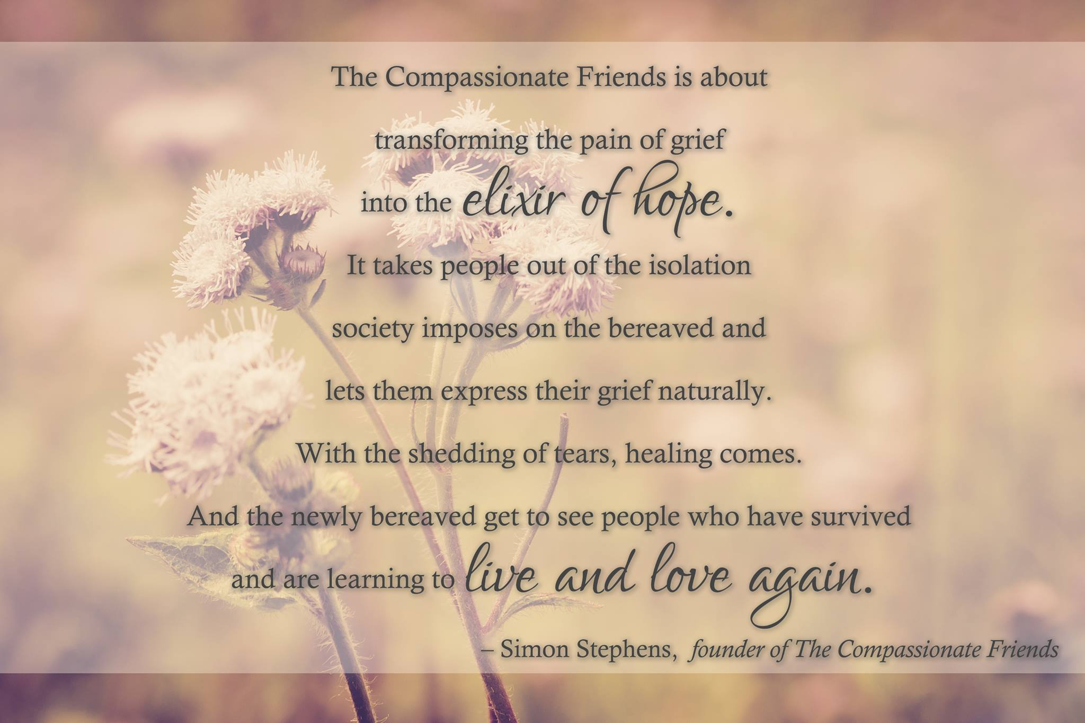

For Remembrance dates please visit our
website at www.easternjacksoncountytcf.org

At first
my very name was grief.
My thoughts were grief
and everything I touched
was turned to grief.
But now
I own the light of memories.
My eyes can see you,
and my thoughts can know you
for what you really are:
more than a young life lost,
more than a radiance
gone into night.
Today you have become
a gift beyond my grief,
a treasure to my world
though you have left
my world and me behind.
--Sascha Wagner, Wintersun
.
First Anniversary
A year has come and gone since I held you in my arms, the day you died. It seems like a blink of an eye on the one hand and an eternity on the other. Many people thought of you on this day. Some were able to share their sadness with me and we shed tears together. Others didn’t want to upset me, so they didn’t mention your name. How can anyone believe that I don’t think about you unless they say your name? I guess that people don’t really understand the constant emptiness I feel without you, or the good feeling I get when someone lets me know that they remember you.
I wish I could say to friends & family:
When you see me crying at the mention of Ali’s name, they are tears of pain and an expression of grief. I must cry in order to heal. Please make it comfortable for me to express my feelings so that I can progress through my grief.
The steps I am taking are baby steps. Please don’t expect me to return to normal just because a year has passed since my daughter’s death. The fact is that I’ll never be the per-son I was before this terrible tragedy occurred. I’m a different person now. Please be patient with me because I don’t know the new me yet.
I will never forget my daughter or the joy and love she brought to my life. It helps me to know that others remember her too. Please share your memories with me so that Ali may live for a few moments as you saw her.
There are no shortcuts through grief. Please don’t push me. I need to feel and experience my grief without a set time-table, without expectations I cannot live up to. I know you care & are concerned, but you can’t take this pain from me the way you would like to. I do need you for support and acceptance.
This is the first of many anniversaries. I can’t imagine the pain lessening, although many say it does. I just know I made it through the first of everything without Allison, and I am beginning the second year, wounded but alive.
--Grace Kuther, TCF Manhattan


Communion
On the first anniversary of your death,
I went to the kitchen,
set the table with your Superman placemat
and pulled up your chair.
I made a peanut butter and jelly sandwich,
and removed the crust as always
for a special occasion.
I cut it into quarters and arranged the triangles on your red plate.
I poured milk in your blue plastic
Crayola crayon mug, put on its pointed top
with the hole in the tip for a straw.
I had no straws.
I don’t buy them anymore.
Sitting next to your place,
I apologized for no straw.
I apologized for your death.
I apologized for not being there.
When I finished,
I wiped my eyes with your napkin,
gave thanks,
ate the bread
and drank the milk.
--Shelley Wagner,
The AndrewPoems

Two Years Later
It has been two years, and it seems like yesterday. The pain is two years older, but still the same; the tears are two years older, but still the same. Will it be three times worse next year, or four times worse the next? I don’t know.
Bradley is two years older and will not remember you, except for the things I can tell him. I sit him on the counter next to the refrigerator, and he looks at the pictures I have on it of him and his big brother. I ex-plain to him that he was only two when you were killed. He won’t remember how you used to tape leaves from the trees on the door to your room so he wouldn’t get into your things. He was so afraid of the leaves when they would blow in the yard.
He won’t remember going with us to get your learner’s license, running around wanting cookies and something to drink, distracting you from your test. He was so funny, and you were standing there rolling your eyes at him. He won’t remember riding in the front seat while you drove home, with me in the back. I was so proud. He won’t remember his two short years with you, but he’ll know —I promise.
--Marilyn Baker, TCF Atlanta

